SAMPLE Lucy Movie Storyboard “Mobile Security Awareness Video”

Introduction: Each LUCY Video is split up in different scenes / animations. This video script covers the Mobile Security Awareness video

If you want only a few selected scenes to be altered choose the according scene and provide us with the customized text and a draft of the desired animation. Within the field “animation description” you can specify the details of the animation.

Price calculation: A modification costs about around 100 USD per scene (depends on the complexity of the desired animation). So, if you only want to change the logo at the beginning and the end with the intro voice change it will cost 200 USD. The creation of a customized new video of about 2 mins length with a voice of your choice starts from USD 2’000 (includes voice & image/animation design).

# | Voice-over | Animation Plan | Storyboard
1 | This is a LUCY awareness video | - logo animation
2 | Your mobile device doesn’t just contain private information about you, it often times contains sensitive information about our business. Here are a couple tips on protecting your mobile device. | - Phone appears on the left  - Security icon appears on the phone screen  - Notes appears on the right  - Text animated | 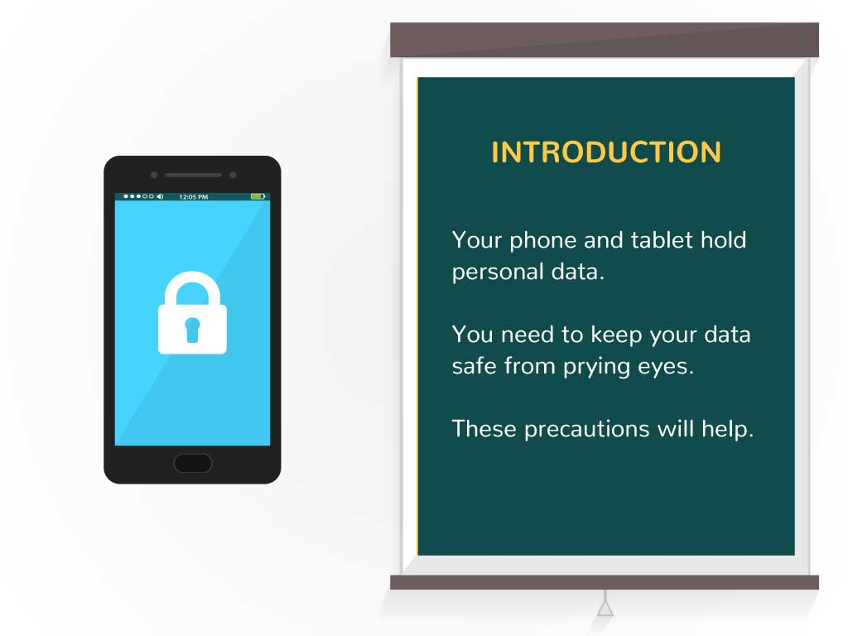  INTRODUCTION  * Your phone and tablet hold personal data.  * You need to keep your data safe from prying eyes.  * These precautions will help.
3 | To protect against viruses and malware, stay up-to-date on your updates. Always maintain the latest version of your mobile antivirus app, web browser, operating system. | - New text appears on the note  - Phone screen changes to cogs (working)  - Cloud appears above | 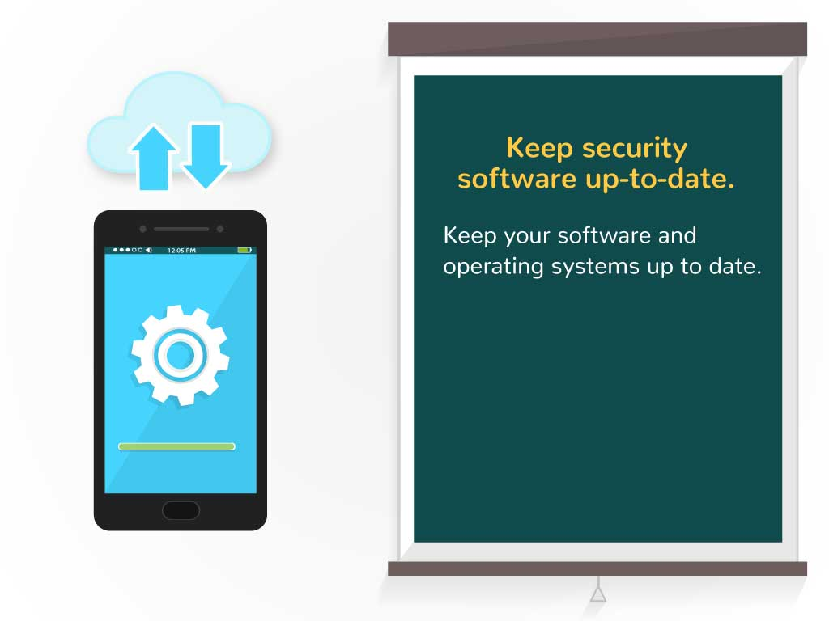  Keep security software up-to-date.  * Keep your software and operating systems up to date.
4 | Many of us download apps that we use once and then forget it. It’s a good security practice to occasionally “clean house” and delete all apps you no longer use. | - New text appears on the note  - Phone on the screen changes  - Hand deletes the apps several times | 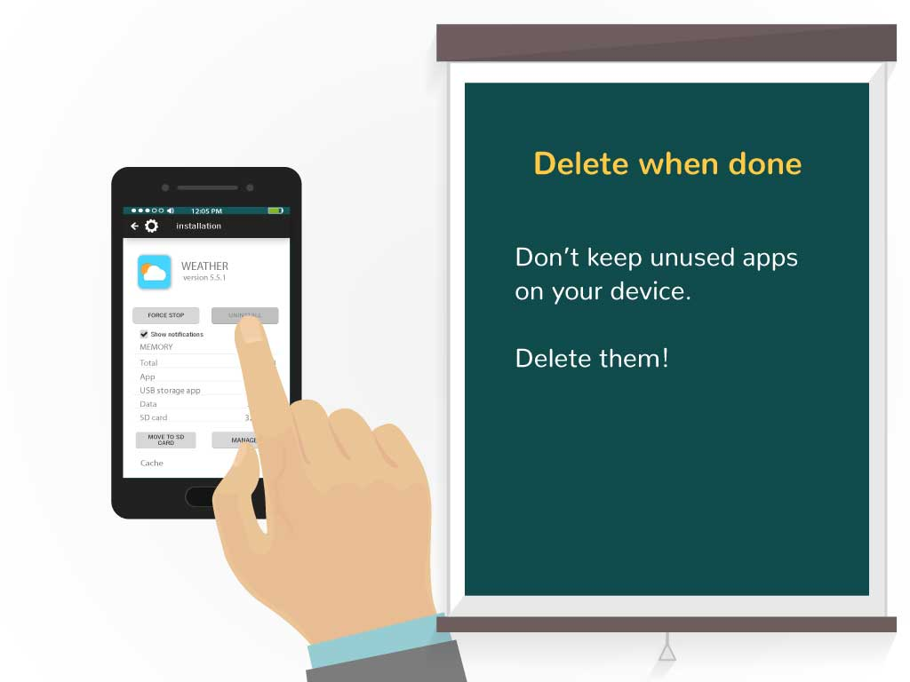  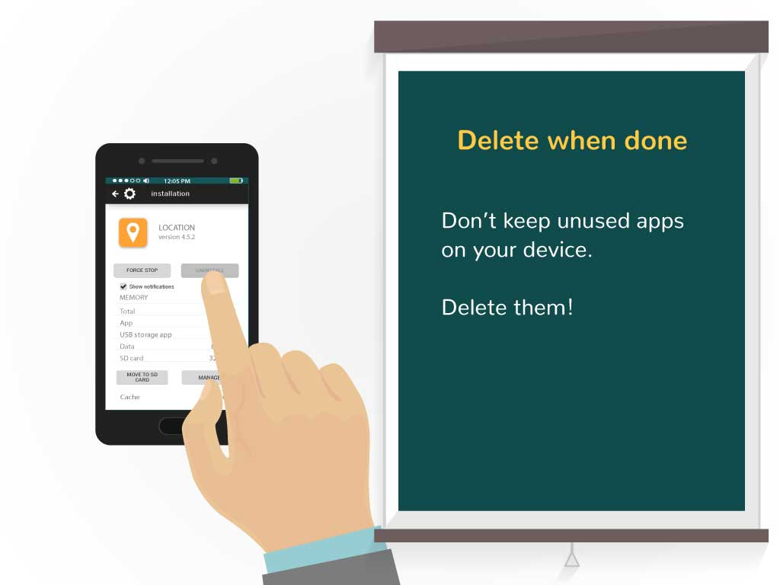  Delete when done:  *Don’t keep unused apps on your device. Delete them!
5 | Use strong passwords, passcodes or other features such as touch identification to lock your devices. Even if your device is lost, your email and other sensitive data is safe. | - New text appears on the note  - Phone has a black screen  - Image appears on the phone and unlocking animation appears | 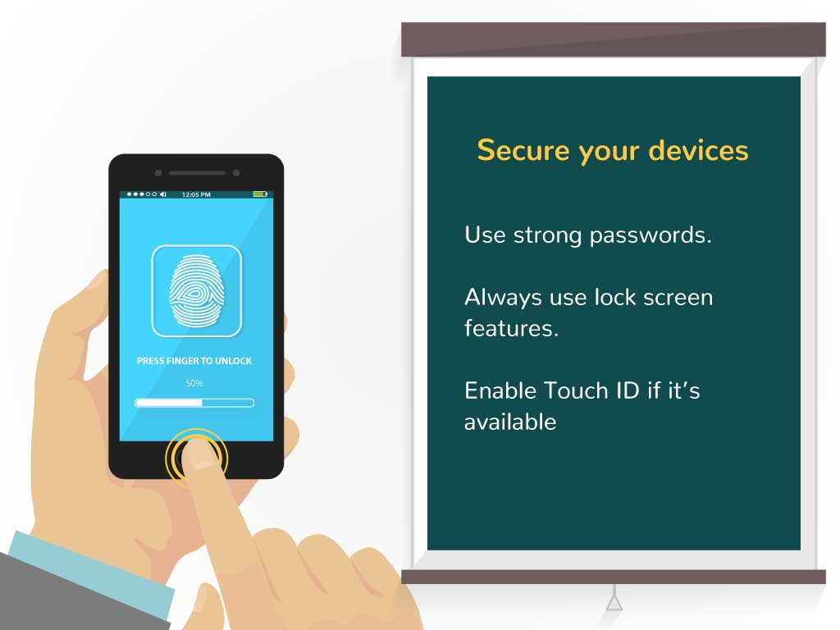  Secure your devices  * Use strong passwords.  * Always use lock screen features.  * Enable touch ID if it’s available
6 | Yep, they’re watching you. Be aware of which apps you allow to access your information as this information can be collected and used in a malicious way | - New text appears on the note  - Screen changes  - Icons of apps appear | 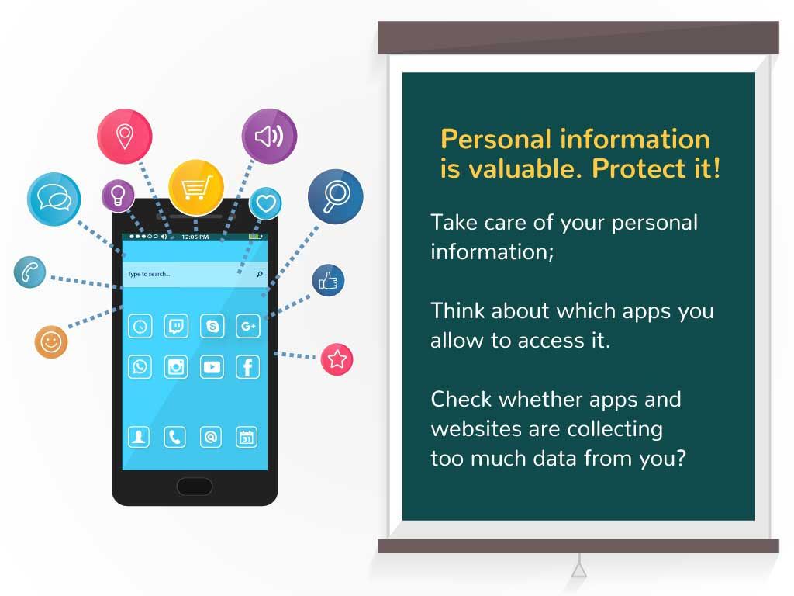  Personal information is valuable. Protect it!  * Take care of your personal information;  * Think about which apps you allow to access it.  * Check whether apps and websites are collecting too much data from you?
7 | and use the security and privacy settings on websites and apps to manage what is shared about you and who sees it. | - New text appears on the note  - Screen changes  - Different options of privacy settings are shown | 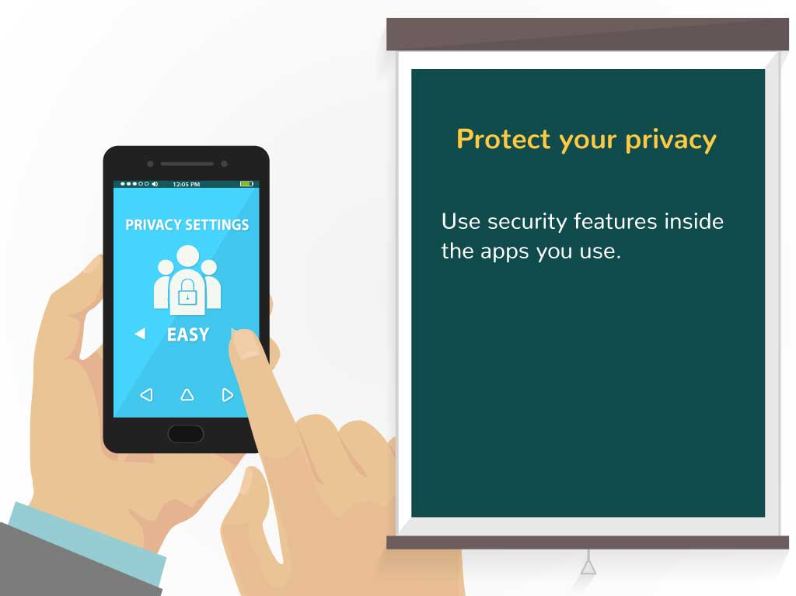  Protect your privacy  *Use security features inside the apps you use.  easy\moderate\hard
8 | Disable WiFi and Bluetooth when not in use as these can be used to track your movement. Some retail stores ae already using this to track their customer’s movements inside their stores. | - New text appears on the note  - Screen changes  - Disconnect button is clicked | 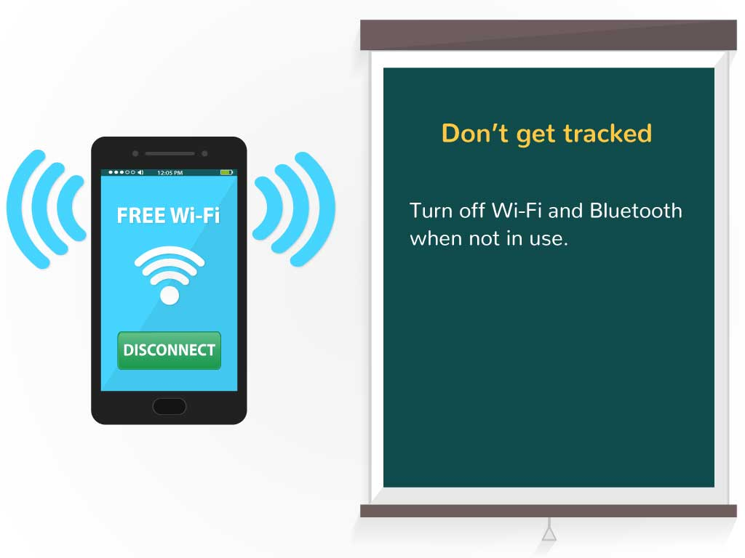  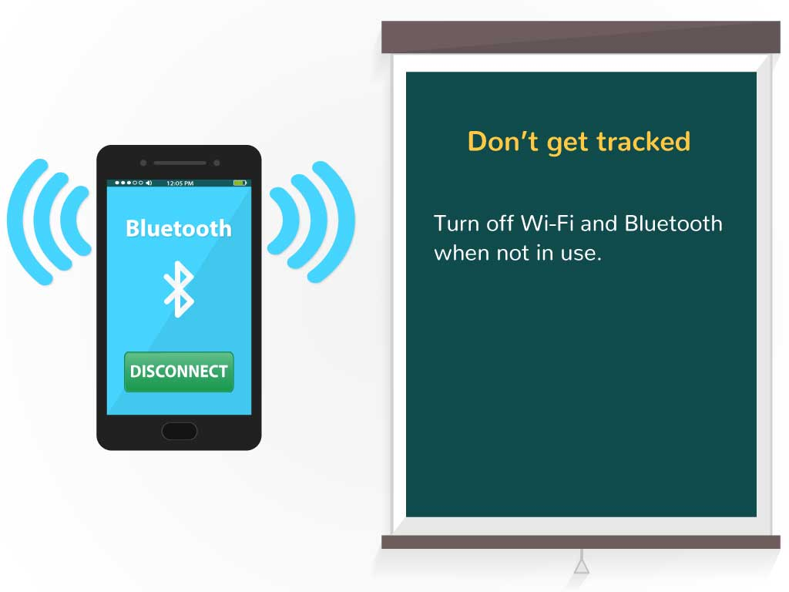  Don’t get tracked  * Turn off wifi and Bluetooth when not in use.
9 | Remember that public wireless networks and hotspots are not secure. Anyone could potentially see what you are doing on your laptop or smartphone while you are connected. Limit what you do on public WiFi, and avoid logging in to key accounts like email or sensitive apps like your online banking. Consider using a virtual private network (VPN) or a personal/mobile hotspot if you need a more secure connection for your business related activities. | - New text appears on the note  - Wi fi router appears  - Phone appears and CONNECT is clicked on it  - Green line “runs” from wi fi to the phone  - Notebook appears below  - Scull appears on its screen  - Line turns from green to red | 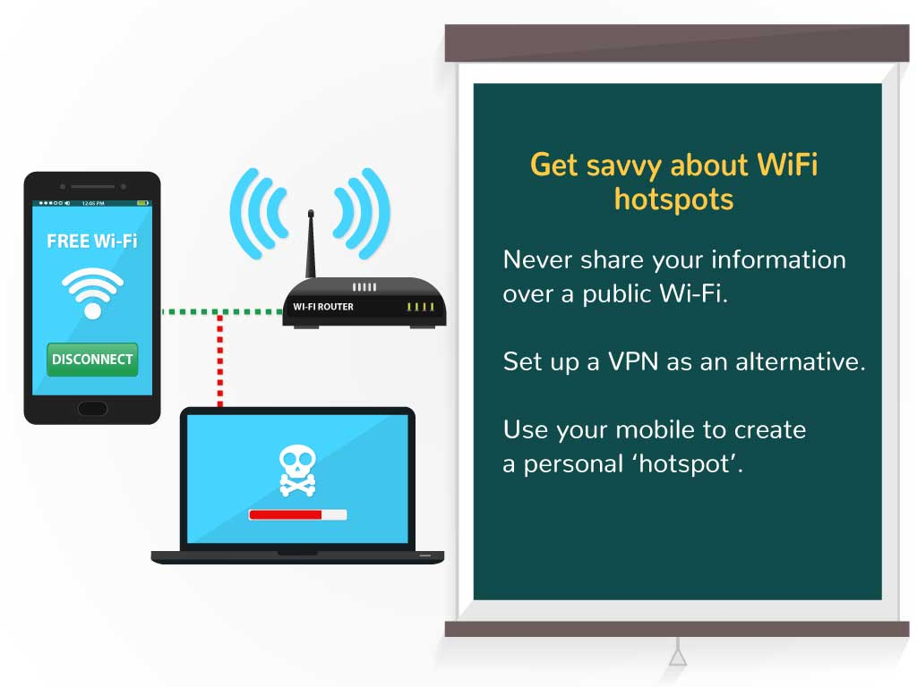  Get savvy about WiFi hotspots  * Never share your information over a public wifi.  * Set up a VPN as an alternative.  * Use your mobile to create a personal ‘hotspot’.
10 | Fraudulent text messages (phishing), calls and voicemails are on the rise. Just as with email, mobile requests for personal data or immediate action are almost always scams. | - New text appears on the note  - Phone appears  - Image appears the screen and login and password is typed  - Hand appears and tries to click the sign in  - Criminal appears behind the phone - the hand stops | 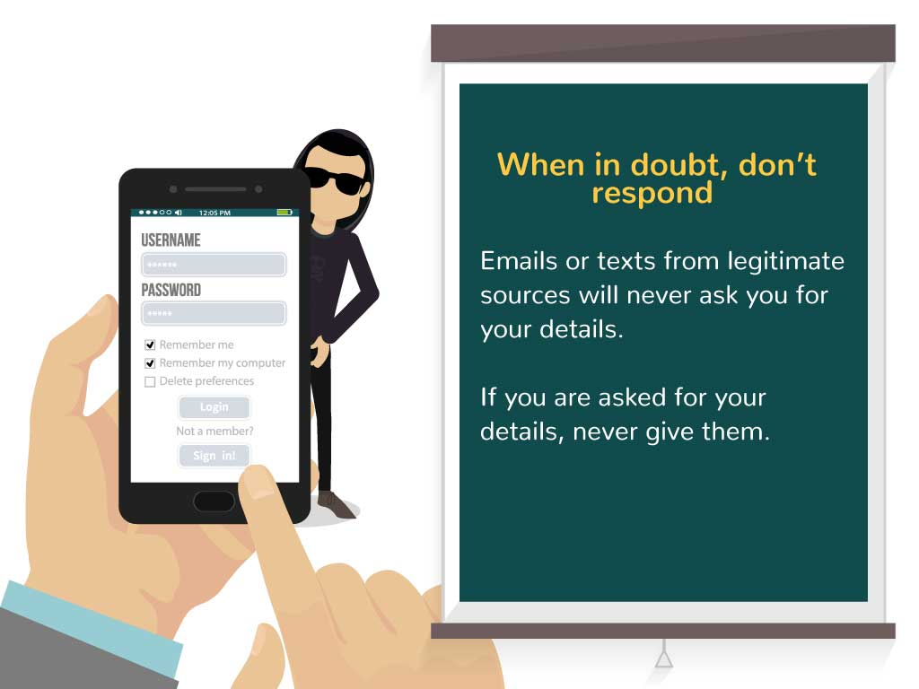  When in doubt, don’t respond  * Emails or texts from legitimate sources will never ask you for your details.  * If you are asked for your details, never give them.
11 | Install remote locate, track, lock, wipe, backup and restore software to retrieve, protect or restore a lost or stolen mobile device and the personal data on that device | - New text appears on the note  - Phone with image appears  - Rubber appears and starts rubbing the password | 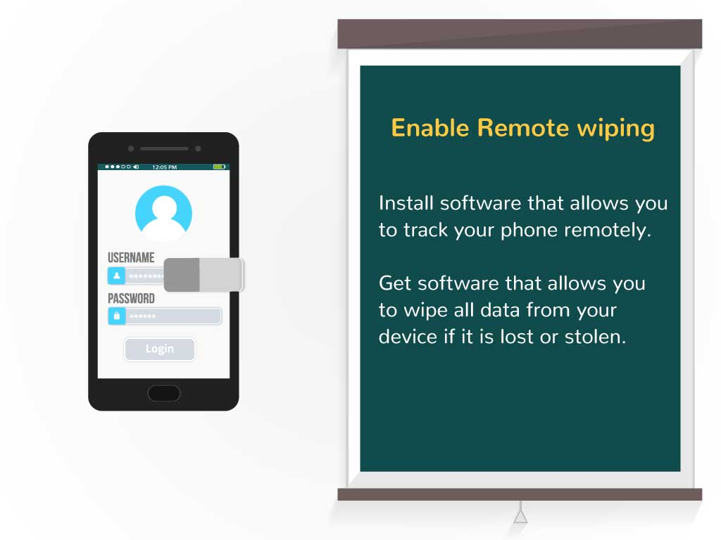  Enable Remote wiping  * Install software that allows you to track your phone remotely.  * Get software that allows you to wipe all data from your device if it is lost or stolen.
12 | Configure your device to lock automatically after a period of time. Only those with knowledge of the passcode can unlock the device. | - New text appears on the note  - Screen changes  - The clock runs  - Then the lock appears | 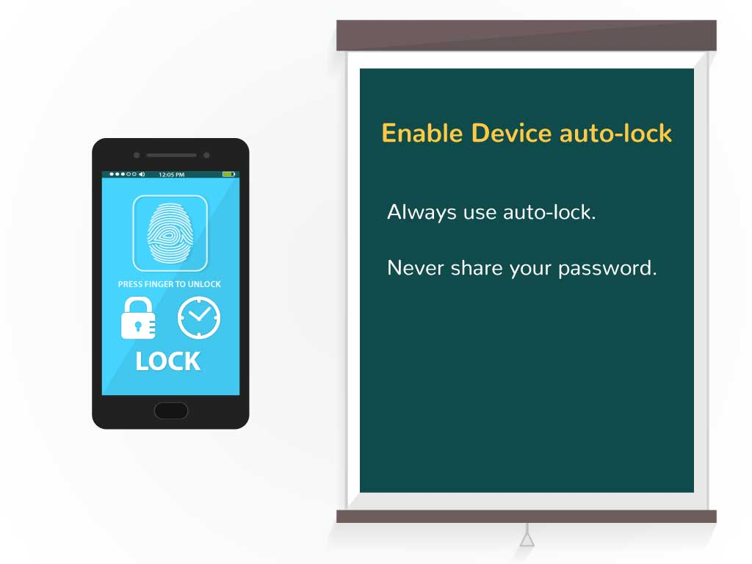  Enable Device auto-lock  * Always use auto-lock.  * Never share your password.
13 | Don't not let your mobile devices be used by children. But if you do, consider disabling in-app purchasing. These downloads are made to appeal to kids but are often malware in disguise. | - New text appears on the note  - Screen changes  - Children icon appears  - Block sign appears on it | 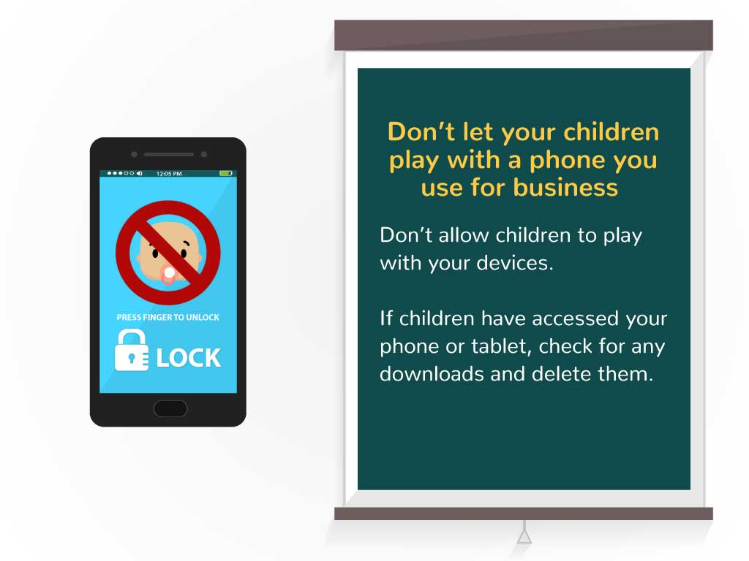  Don’t let your children play with a phone you use for business  * Don’t allow children to play with your devices.  * If children have accessed your phone or tablet, check for any downloads and delete them.
14 | Telephone calls using GSM technology (mobile standard for voice and data) are not eavesdrop-proof. If possible, avoid mobile phones when discussing confidential information. Be aware of your surroundings while you are on the telephone. Who might over hear? | - New text appears on the note  - Screen changes  - Icons appear on the screen 1 by 1 | 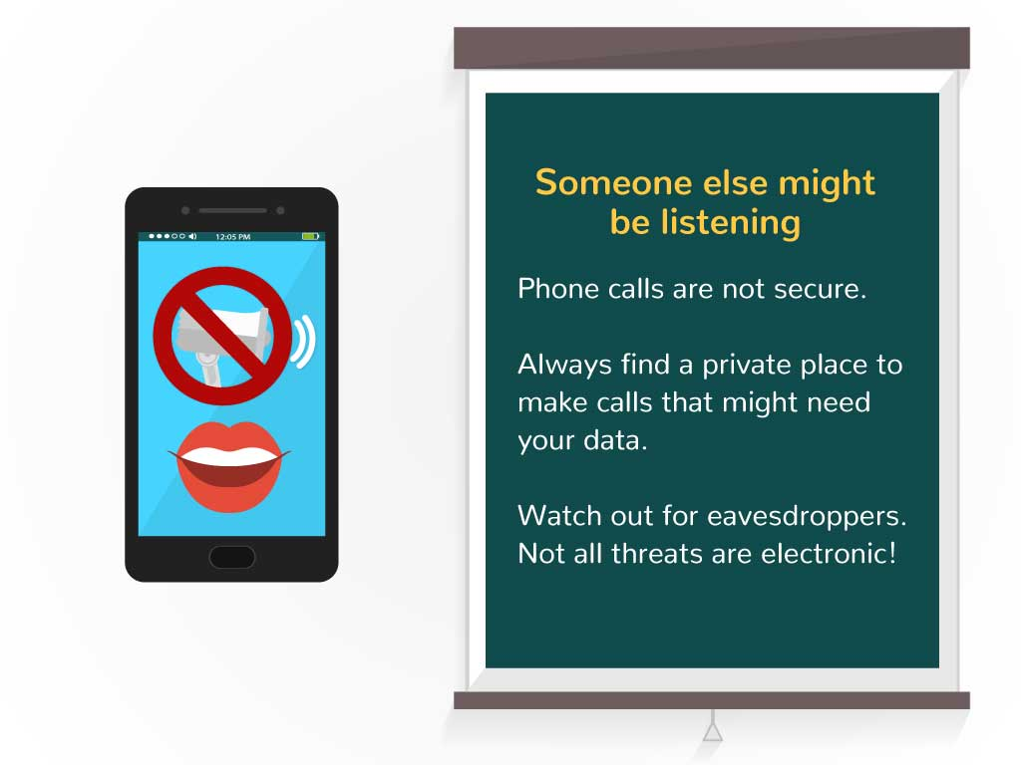  Someone else might be listening  * Phone calls are not secure.  * Always find a private place to make calls that might need your data.  * Watch out for eavesdroppers. Not all threats are electronic!
15 | Bottom Line: Try to always be careful and stay alert to possible threats when handling mobile devices. When you are unsure, immediately direct your questions to your IT colleagues, they are your best resource.  THANK YOU FOR YOUR PARTICIPATION | - Image appears  - Text is animated  - Logo animation at the end | 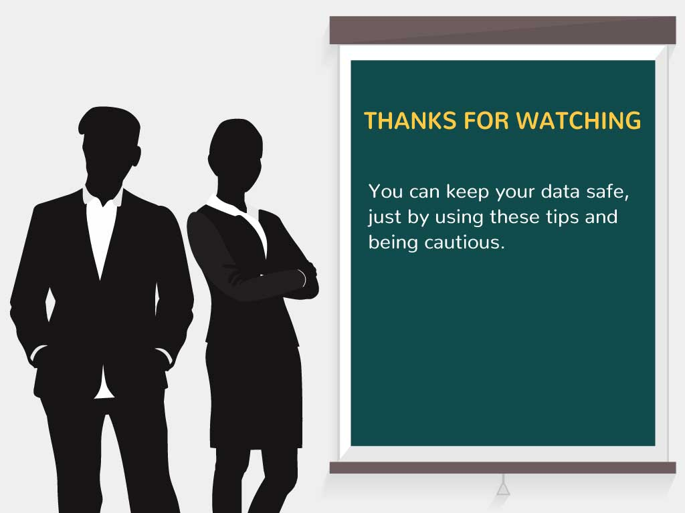  * THANKS FOR WATCHING  * You can keep your data safe, just by using these tips and being cautious.

