SAMPLE Lucy Movie Storyboard “Security Awareness Tips”

Introduction: Each LUCY Video is split up in different scenes / animations. This video script covers the Security Awareness Tips

If you want only a few selected scenes to be altered choose the according scene and provide us with the customized text and a draft of the desired animation. Within the field “animation description” you can specify the details of the animation.

Price calculation: A modification costs about around 100 USD per scene (depends on the complexity of the desired animation). So, if you only want to change the logo at the beginning and the end with the intro voice change it will cost 200 USD. The creation of a customized new video of about 2 mins length with a voice of your choice starts from USD 2’000 (includes voice & image/animation design).

# | Voice-over | Animation Plan | Storyboard
1 | This is a LUCY awareness video. In this short security awareness video, |  | 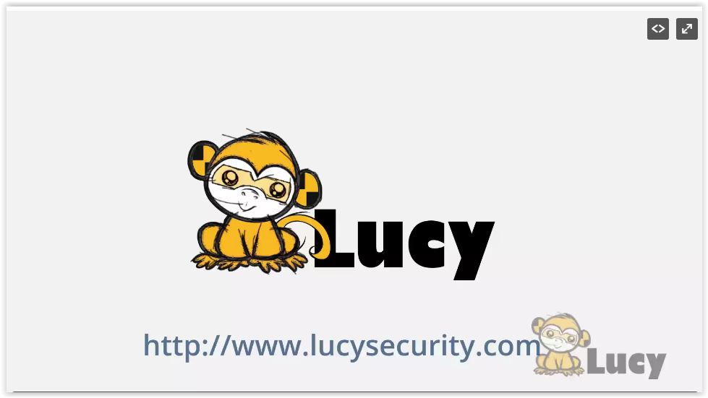
2 | we will give you a few tips on how you can help us stay secure. |  | 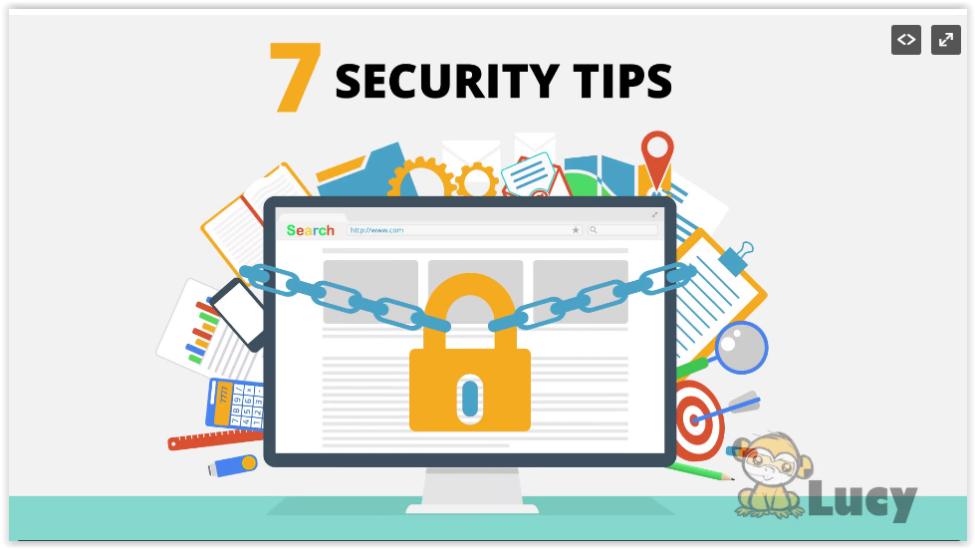  7 SECURITY TIPS
3 | Tip 1: Follow a clean Desk Policy  Following a clean desk policy will help us reduce |  | 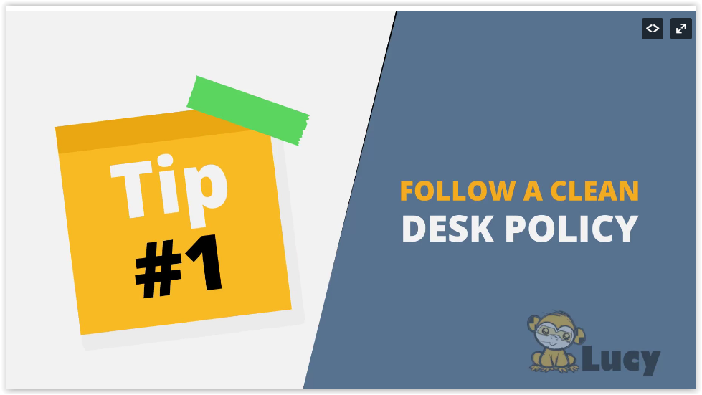  Tip 1  FOLLOW A CLEAN  DESK POLICY
4 | the risk of information theft, fraud, or a security breach caused by sensitive information being left in plain view. |  | 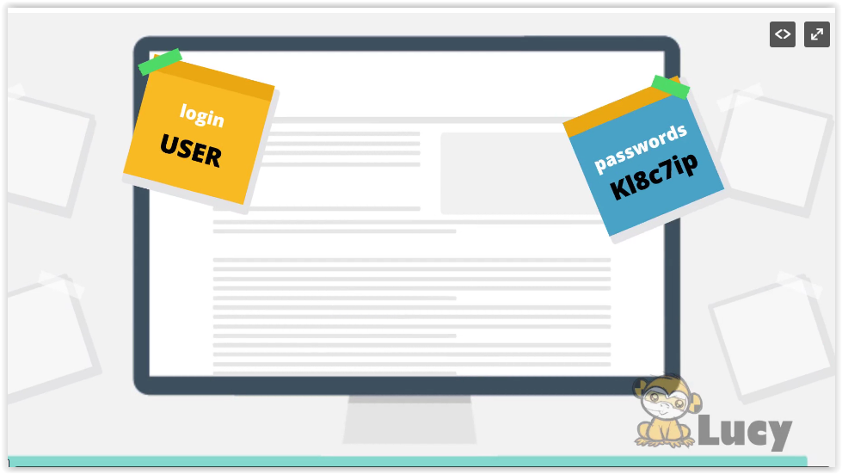  login  USER  password
5 | When leaving your desk, be sure to lock your computer and put away sensitive documents. |  | 
6 | Tip 2:  Be aware when creating or disposing of paper documents. Sometimes an attacker might look through |  | 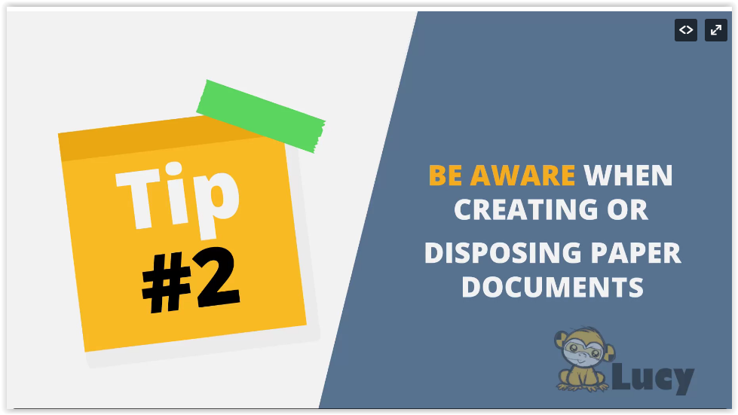  Tip 2  BE AWARE WHEN  CREATING OR  DISPOSING PAPER  DOCUMENTS
7 | your trash hoping to discover useful information that may allow access to your network. |  | 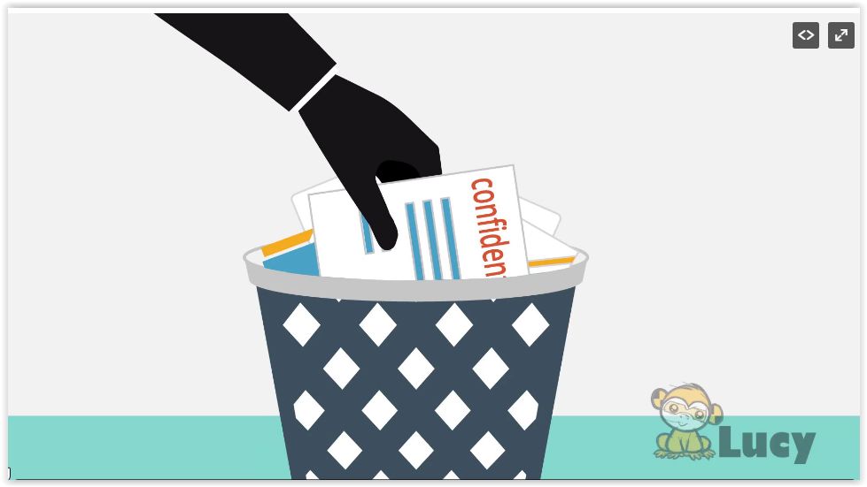  Confidential
8 | Sensitive documents must never be disposed in the wastepaper basket. |  | 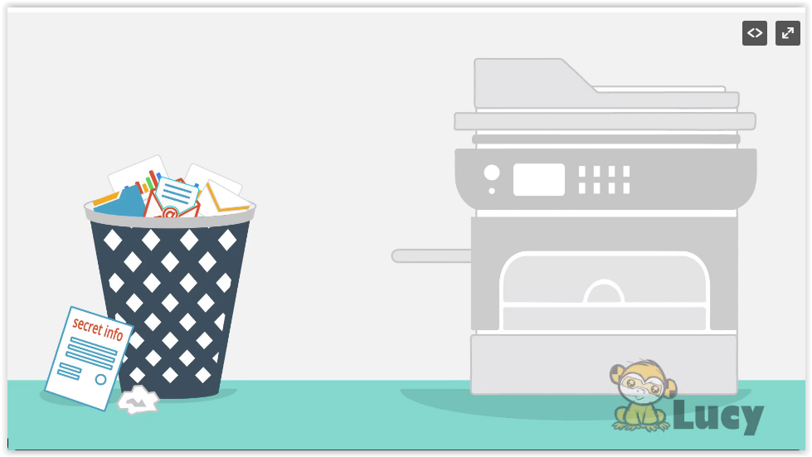  Secret Info
9 | Also, don’t forget: If you print a document, you should always pick up the printouts. |  | 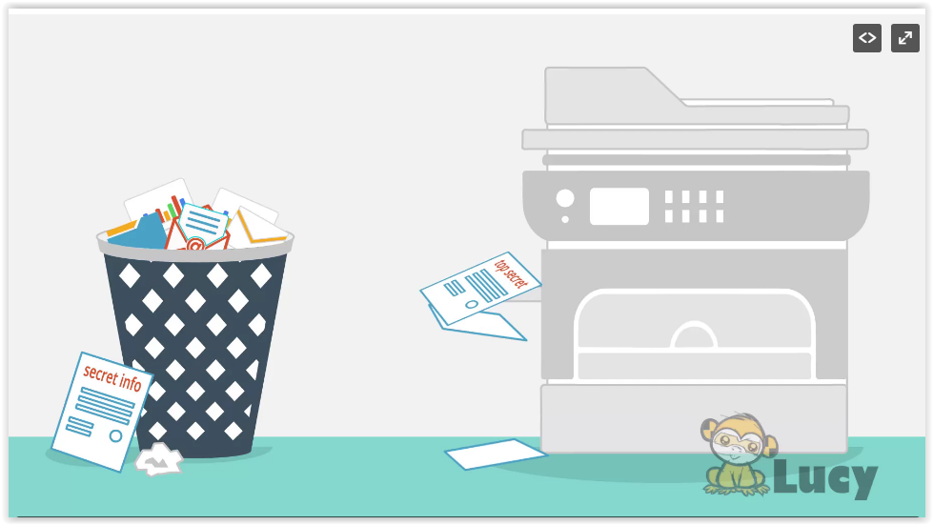  Secret Info  Top Secret
10 | Tip3: Consider carefully what information you put out there |  | 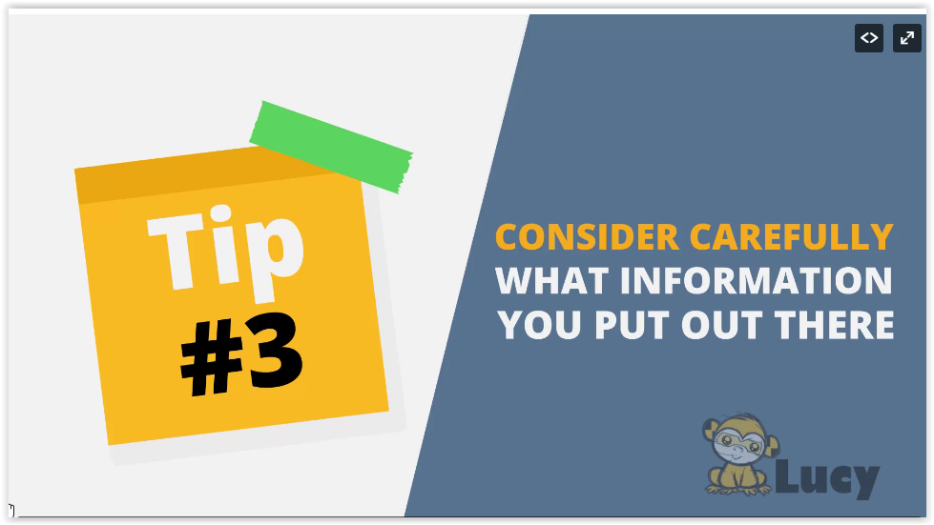  Tip 3  CONSIDER CAREFULLY  WHAT INFORMATION  YOU PUT OUT THERE

11 | Practically anything you have ever posted on the internet can be discovered by cybercriminals. |  | 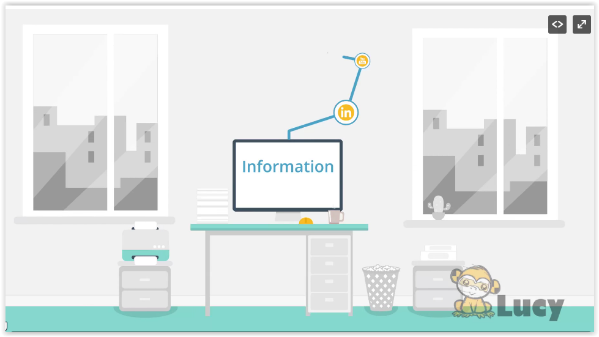  Information
12 | What might seem like a harmless post, could help an attacker prepare a targeted attack against you. |  |   SOCIAL MEDIA  NETWORK  CHAT  SHARE  SEARCH  VIRAL MEDIA  TWEET  SMS
13 | Tip 4: Prevent unauthorized people accessing your company. An attacker may try gain access |  | 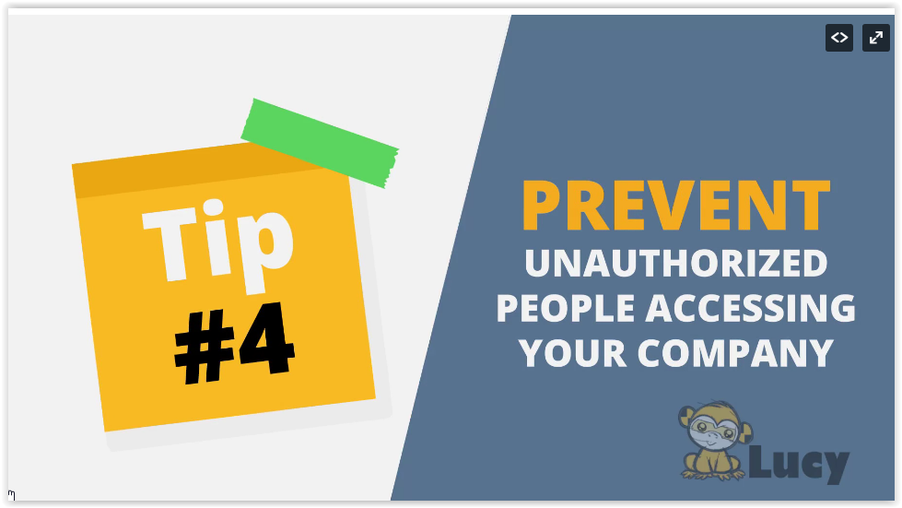  Tip 4  PREVENT  UNAUTHORIZED  PEOPLE ACCESSING  YOU COMPANY
14 | to the building by pretending to be an employee, visitor or service personnel. |  | 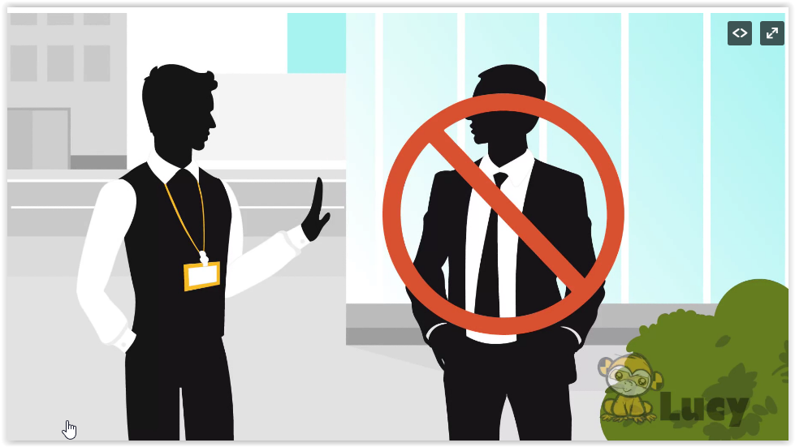
15 | If you see a someone you don’t know without a badge don’t be shy to approach them. |  | 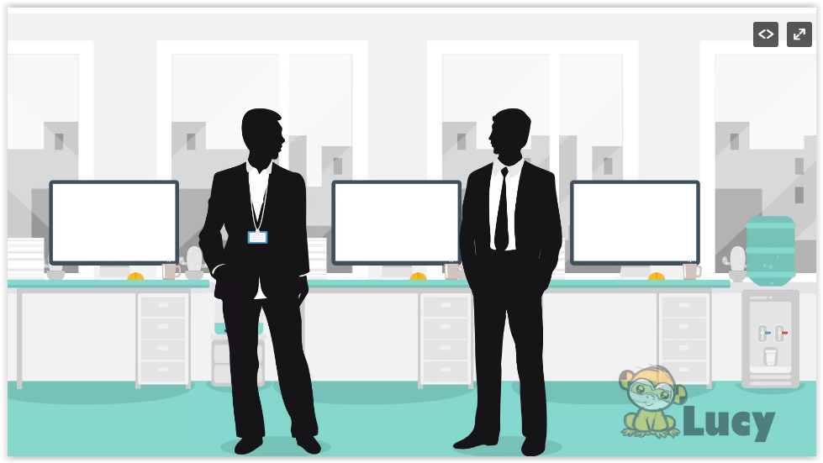
16 | Ask for their contact person so that you may verify their identify |  | 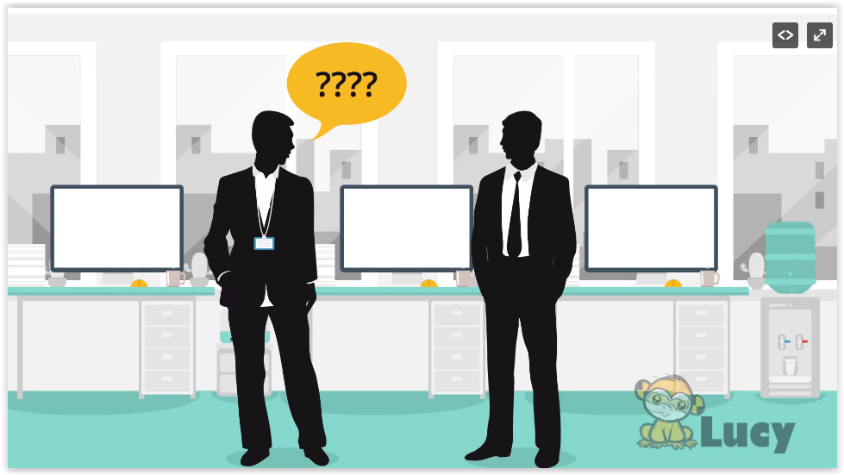
17 | Tip 5: Just because they know you, doesn’t mean, you know them! Voice phishing occurs |  | 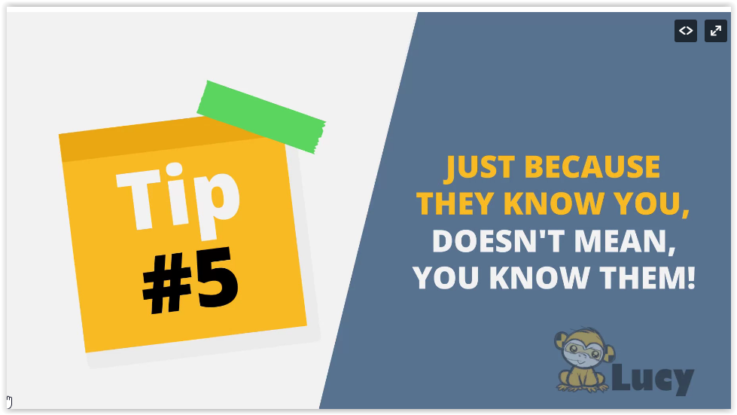  Tip 5  JUST BECAUSE  THET KNOW YOU,  DOESN’T MEAN,  YOU KNOW THEM!
18 | when trained fraudsters trick unsuspecting people into giving out sensitive info over the telephone |  | 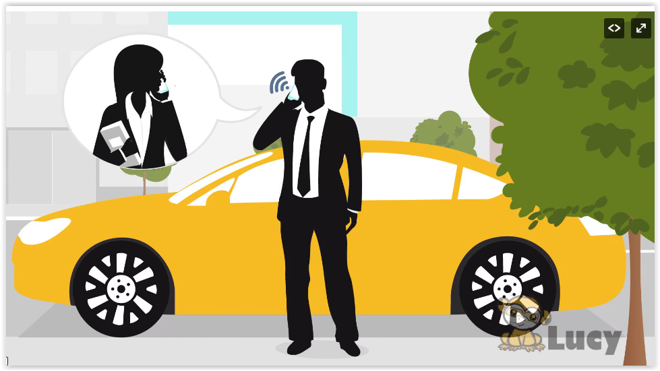
19 | Tip 6: Phishing Scams: don’t bite  Through phishing, potential hackers might try to acquire |  | 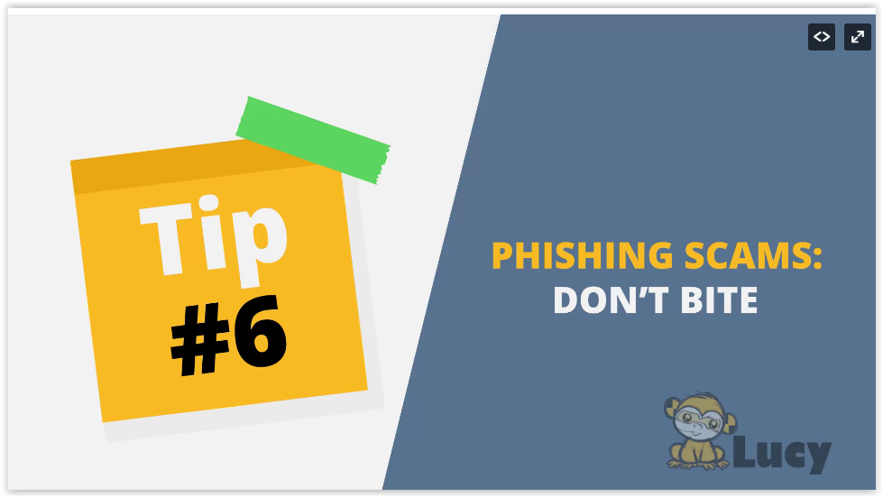  Tip 6  PHISHING SCAMS:  DON’T BITE
20 | information such as usernames, passwords or get you to download malware. |  | 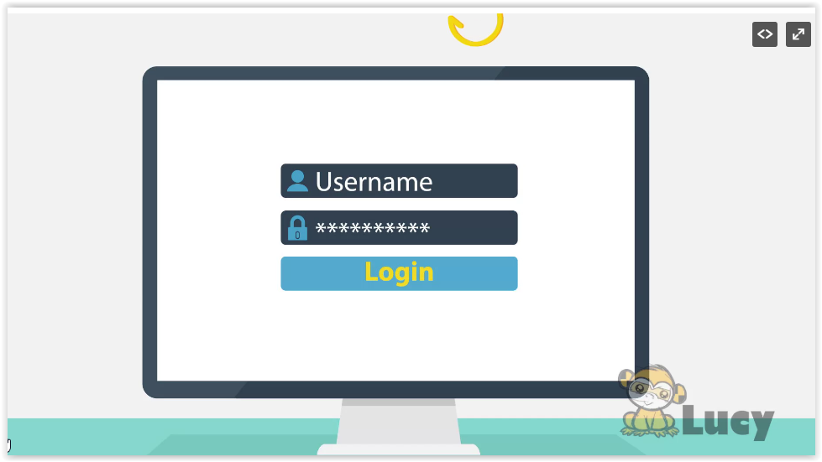  Username  Login
21 | Be especially cautious of emails that come from unrecognized senders. Never confirm personal or |  | 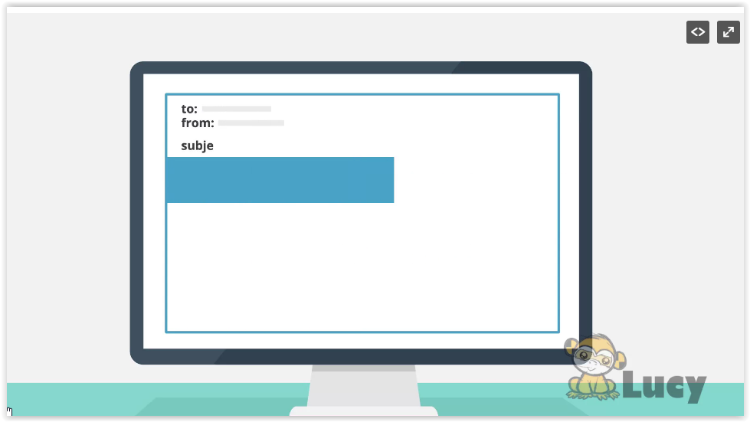
22 | financial information over the internet. If you get a suspicious mail, |  | 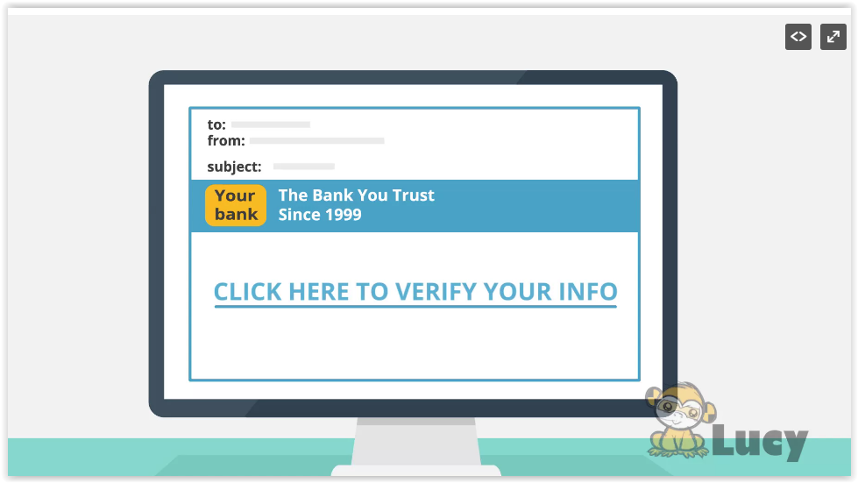  to:  from:  subject:  Your bank  The Bank You Trust Since 1999  CLICK HERE TO VERIFY YOUR INFO
23 | do not open it. Forward it immediately to your IT security department. |  | 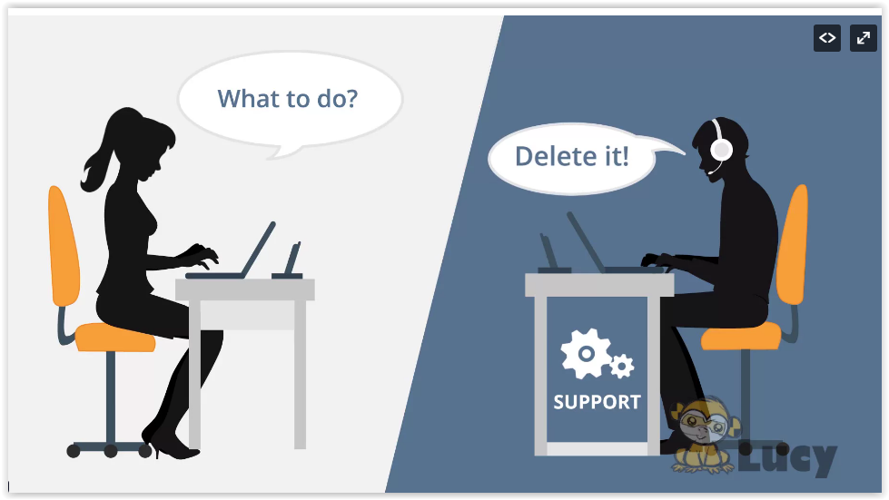  What to do?  Delete it!  SUPPORT
24 | Tip 7: Prevent damage from malware  When you don’t know or trust the sender: |  | 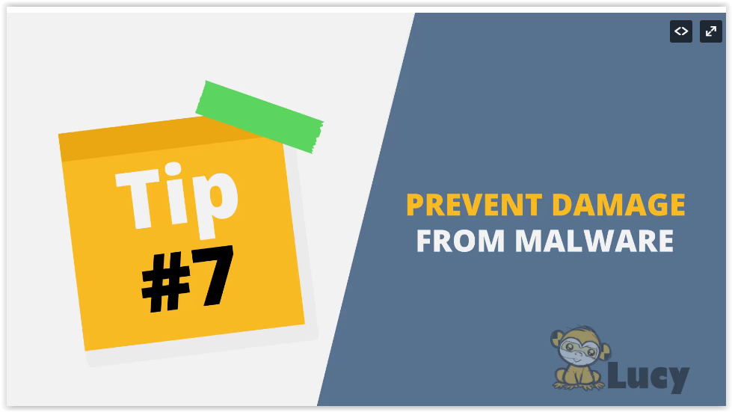  Tip 7  PREVENT DAMAGE  FROM MALWARE
25 | ...do not open mail attachments...  Same goes for macros in office documents... |  | 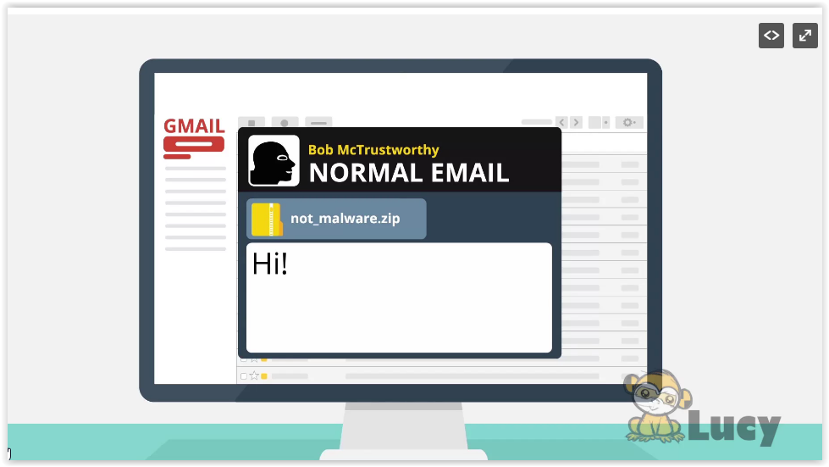  GMAIL  Bob McTrustworthy  NORMAL EMAIL  not_malware.zip  Hi!  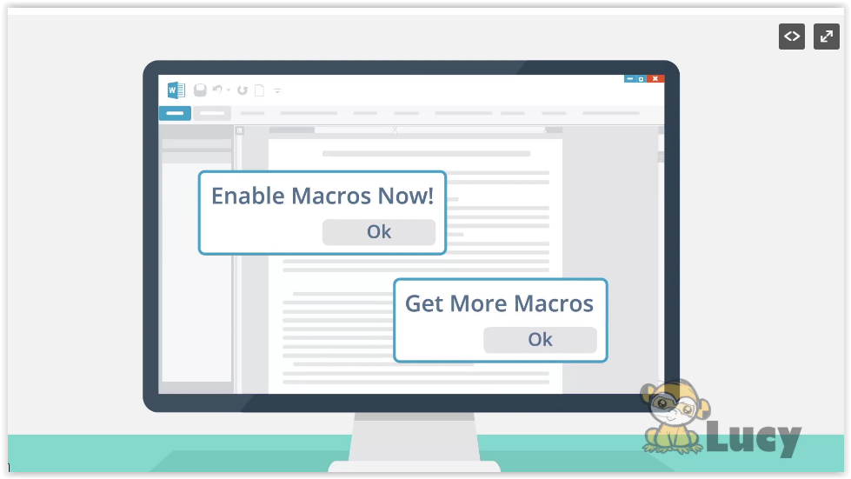  Enable Macros Now!  Ok  Get More Macros  Ok
27 | Never plug in USB devices from untrusted sources. If you follow these safeguards and report |  | 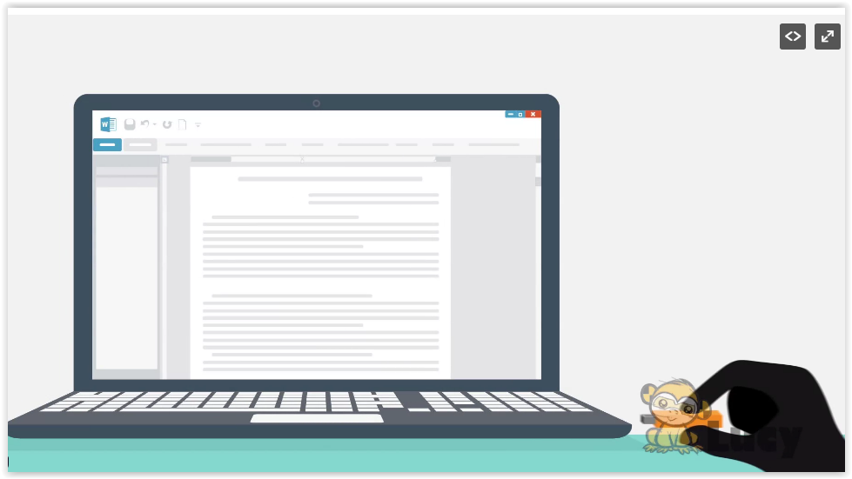
28 | anything suspicious to your it department right away. YOU do your part to protect US from cyberthreats! |  | 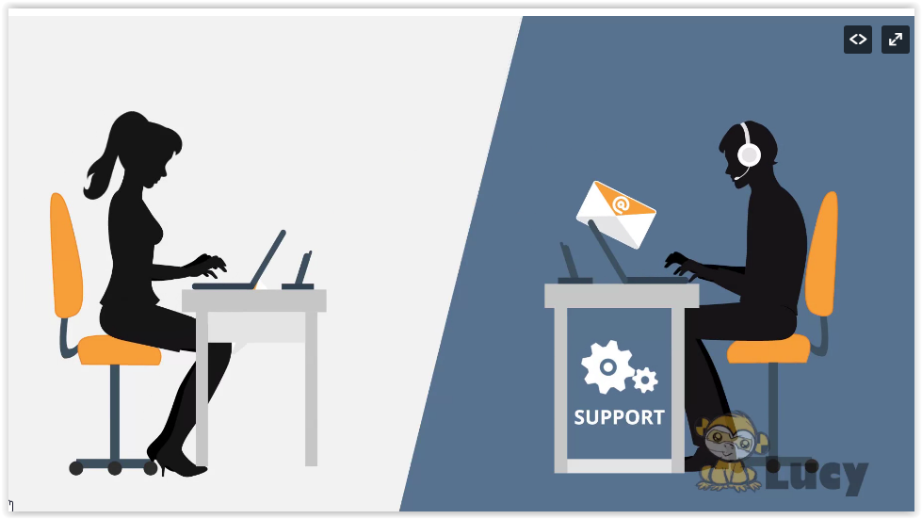  SUPPORT
29 | Thank you and be safe! |  | 