SAMPLE Lucy Movie Storyboard “Ransomware Awareness Video”

Introduction: Each LUCY Video is split up in different scenes / animations. This video script covers the Ransomware Awareness Video

If you want only a few selected scenes to be altered choose the according scene and provide us with the customized text and a draft of the desired animation. Within the field “animation description” you can specify the details of the animation.

Price calculation: A modification costs about around 100 USD per scene (depends on the complexity of the desired animation). So, if you only want to change the logo at the beginning and the end with the intro voice change it will cost 200 USD. The creation of a customized new video of about 2 mins length with a voice of your choice starts from USD 2’000 (includes voice & image/animation design).

# | Voice-over | Animation Plan | Storyboard
1 | This is a Lucy awareness video |  | 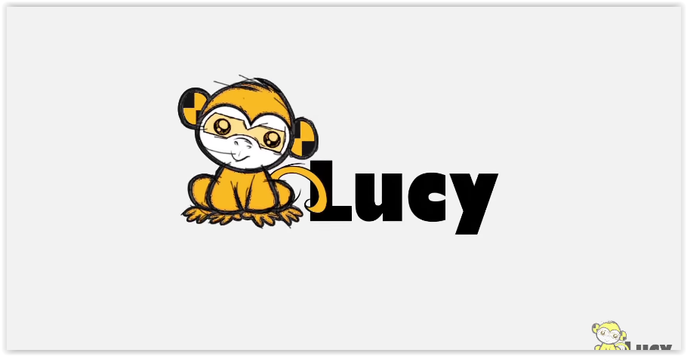
2 | You have already heard of malware |  | 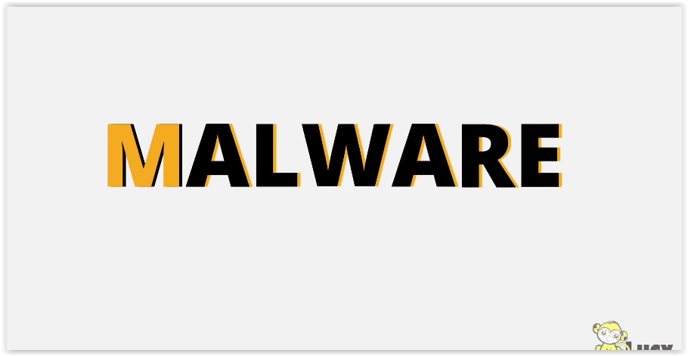
3 | Hiding within downloads of websites |  | 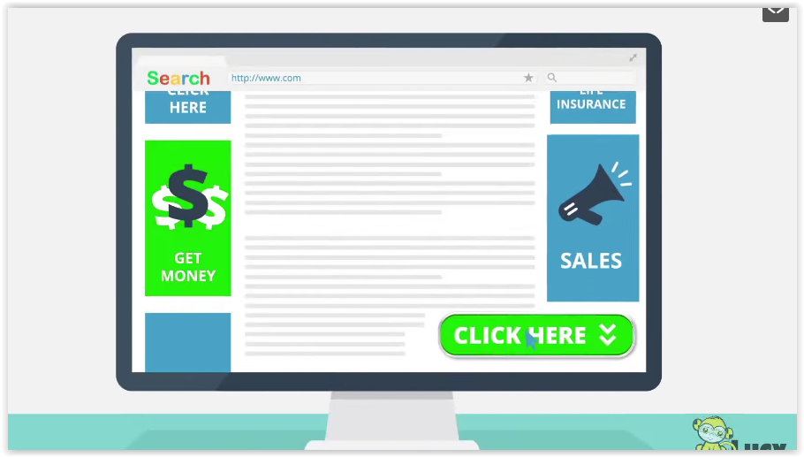  SEARCH  CLICK HERE LIFE INSURANCE  GET MONEY SALES  CLICK HERE
4 | Or appearing in your inbox is |  | 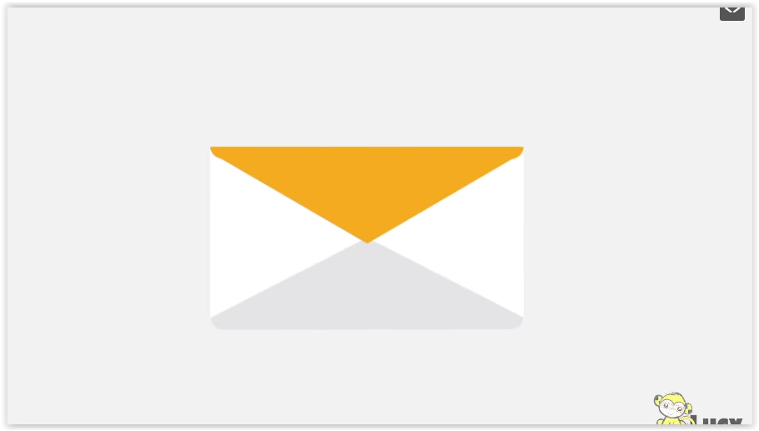
5 | A harmless looking email attachment |  | 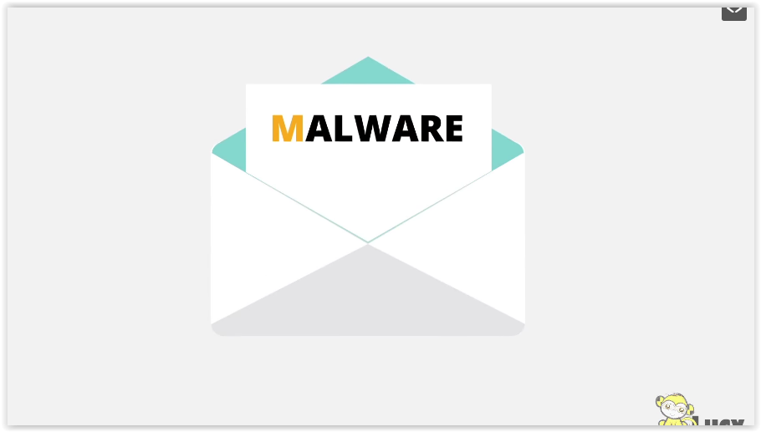
6 | Well, most malware are design to steal your confidential data |  | 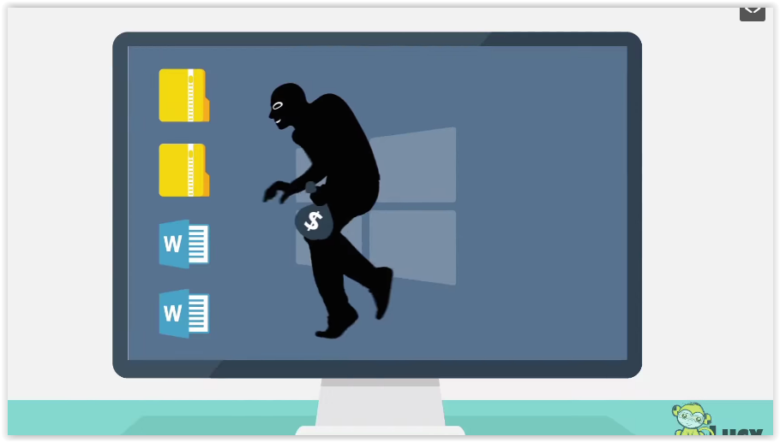
7 | There is a new even more dangerous attack out there |  | 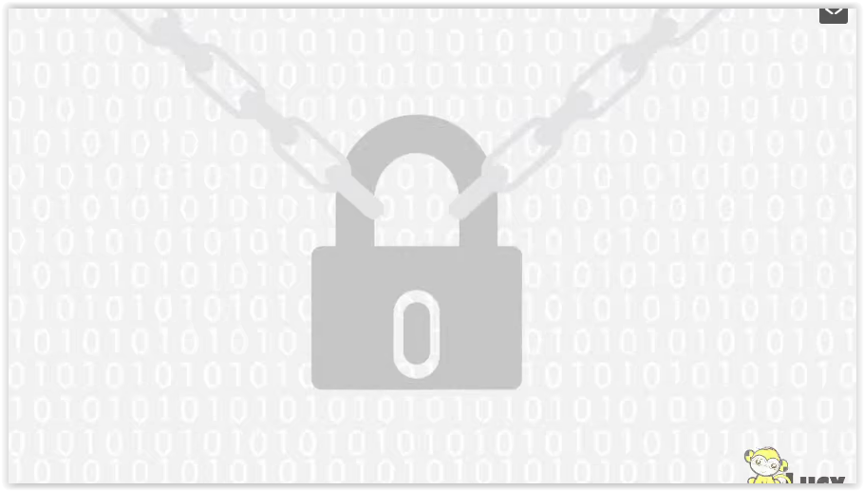
8 | Ransomware |  | 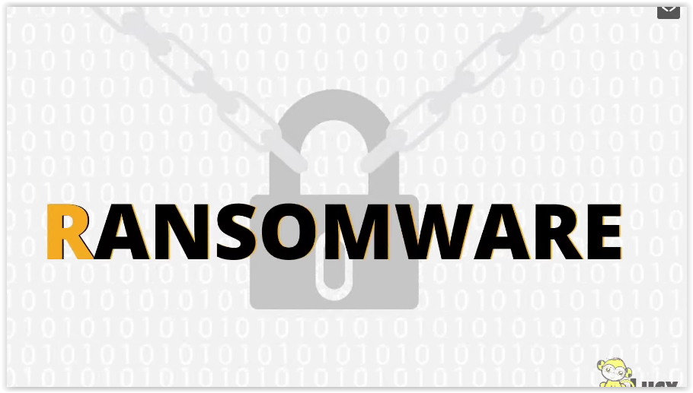
9 | Ransomware encrypts files |  | 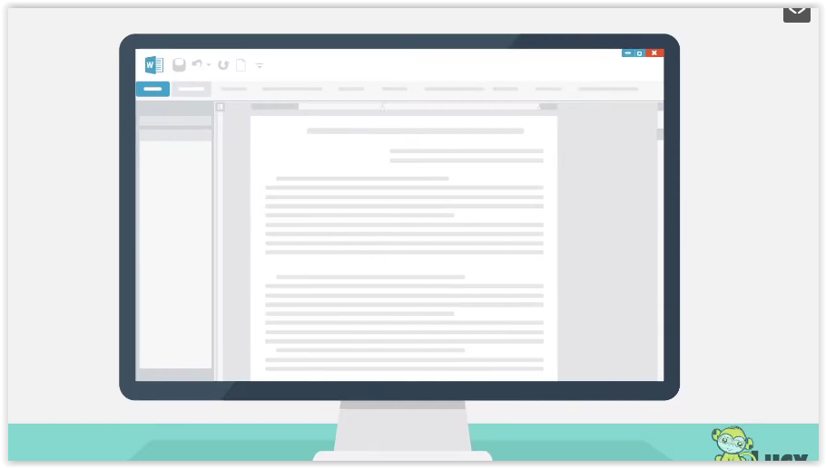
10 | Or hold the computer hostage by restricting the access |  | 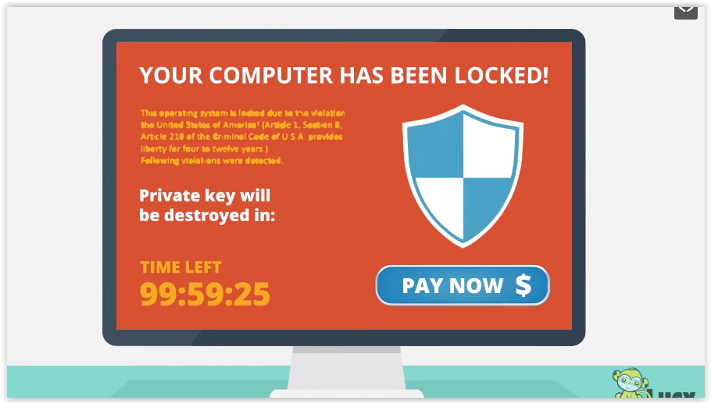  YOUR COMPUTER HAS BEEN LOCKED!  PRIVATE KEY WILL BE DESTROYED IN:  TIME LEFT PAY NOW

11 | After the system is kidnap |  | 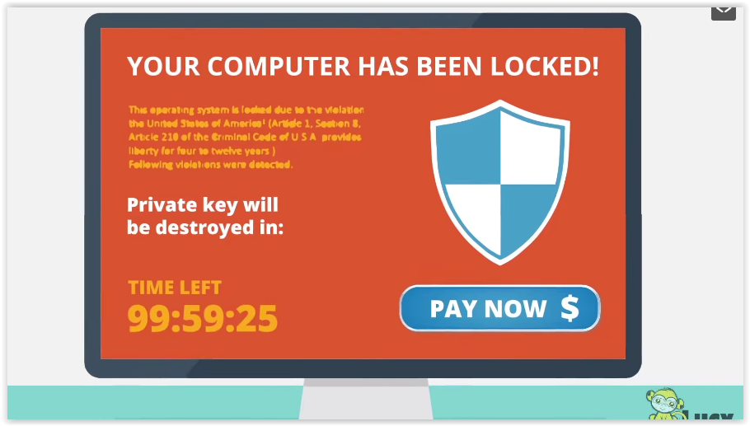
12 | The cyber criminals demand ransom money |  | 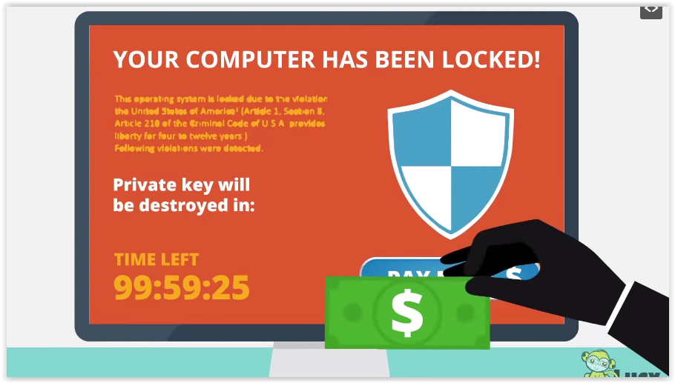  YOUR COMPUTER HAS BEEN LOCKED!  PRIVATE KEY WILL BE DESTROYED IN:  TIME LEFT PAY NOW
13 | To restore the files or unlock the computer |  | 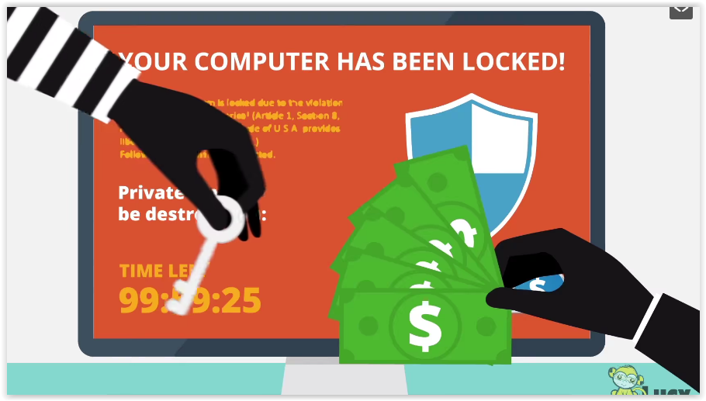
14 | So, how do hackers pull this off? |  | 
15 | Quite simple, by exploiting the most vulnerable part of the organization You, and your fellow employees |  | 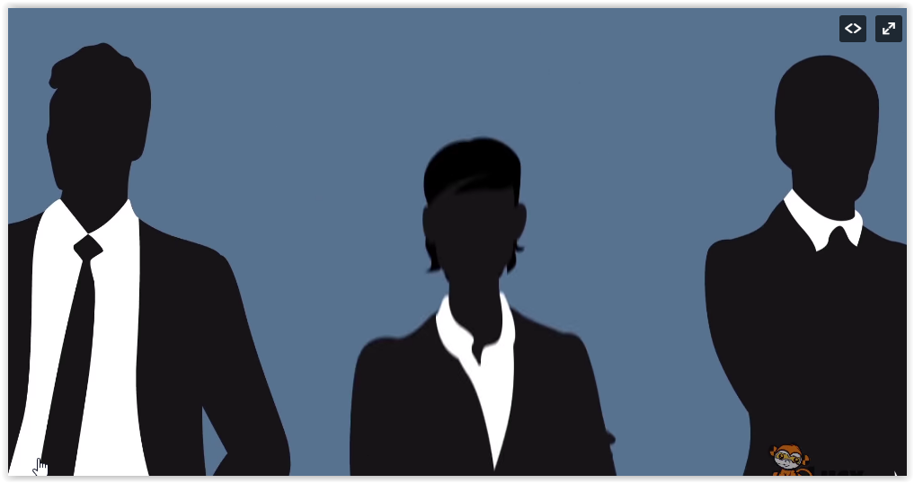
17 | When paying the ransom is not an action |  | 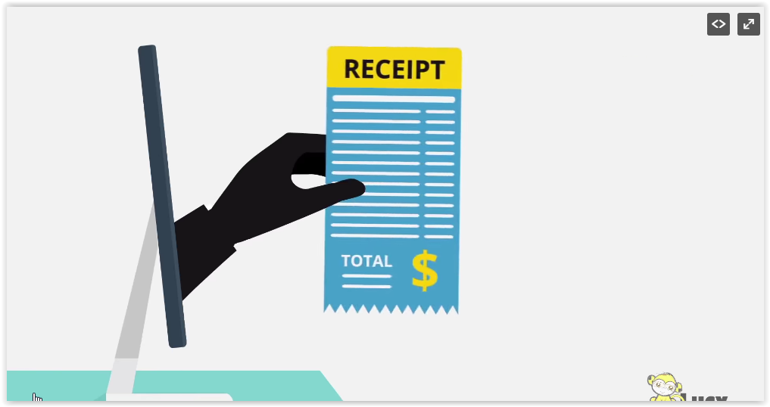  RECEIPT  TOTAL
18 | What can you do? |  | 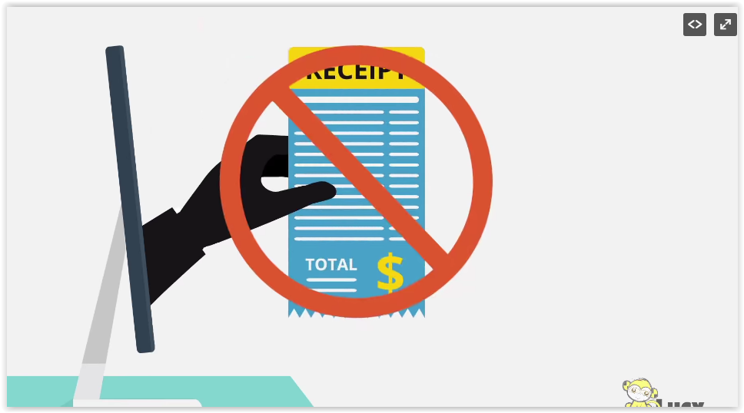
19 | Prevention is the key |  | 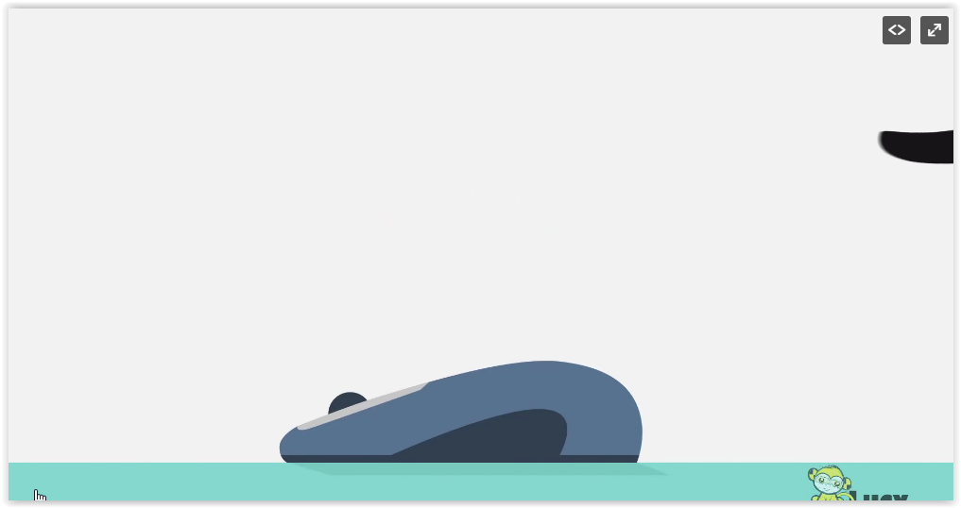
20 | Think before you click |  | 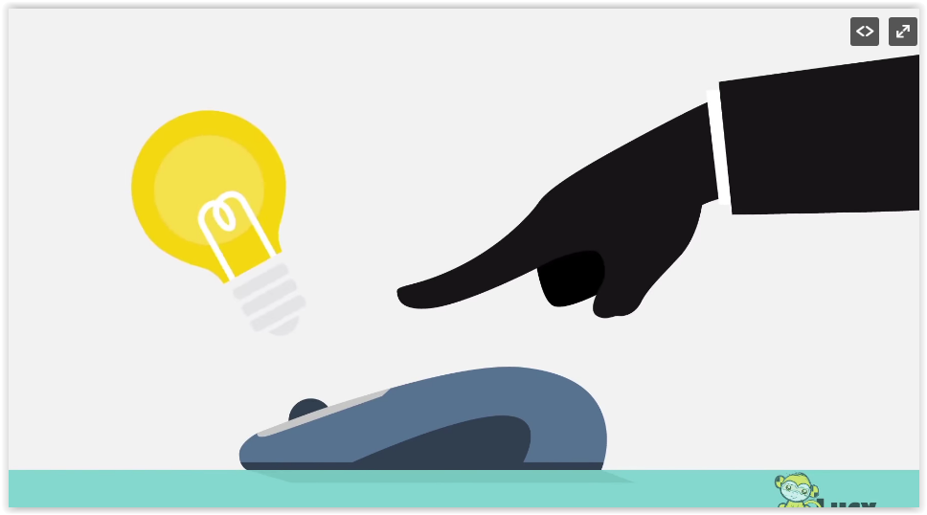
21 | Be a little sceptical when you see download links or advertisement |  | 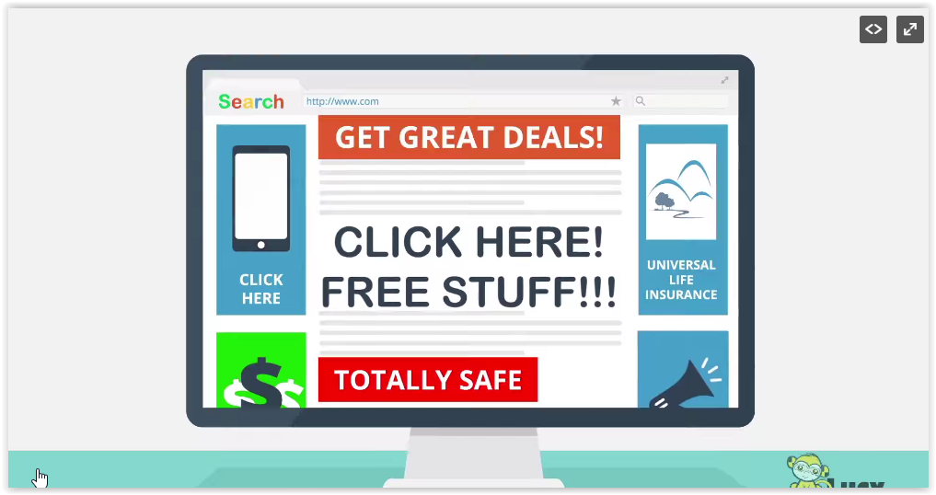  SEARCH  GET GREAT DEALS!  CLICK HERE UNIVERSAL LIFE INSURANCE  CLICK HERE! FREE STUFF!!!  TOTALLY SAFE
22 | A hacker could have created them |  | 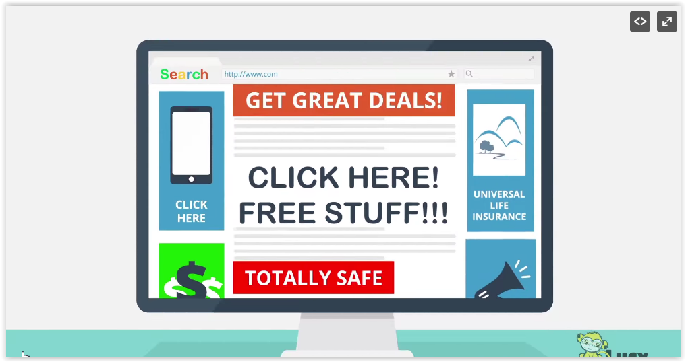
23 | Don’t open mail attachment from unidentified senders or someone you don’t trust |  | 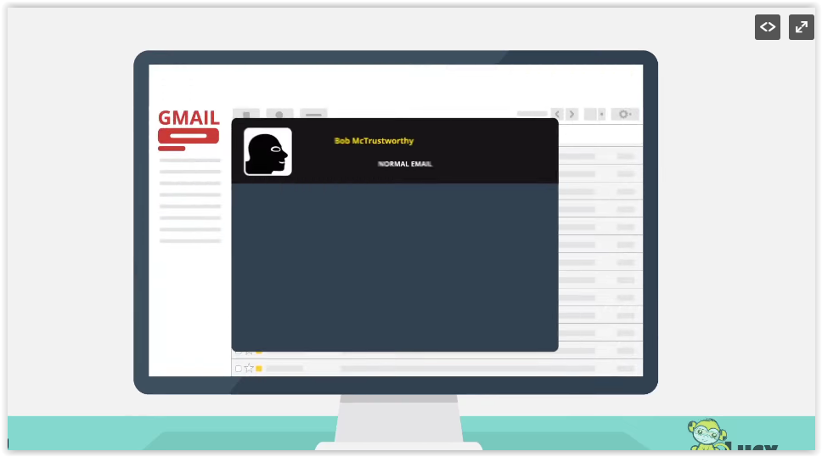  GMAIL
25 | Never enable macros in office documents |  | 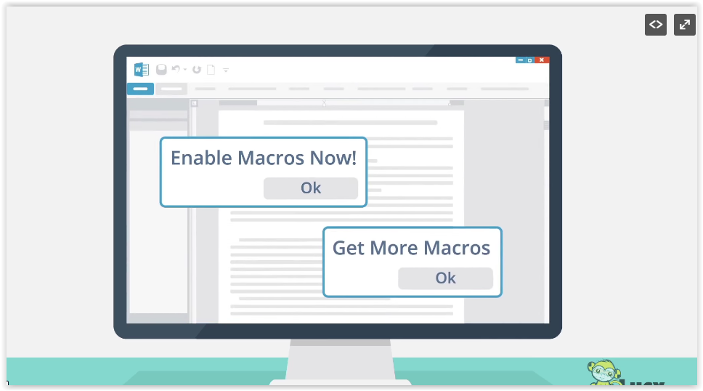  ENABLE MACROS NOW!  OK  GET MORE MACROS  OK
26 | If you are not absolutely sure, you know the sender |  | 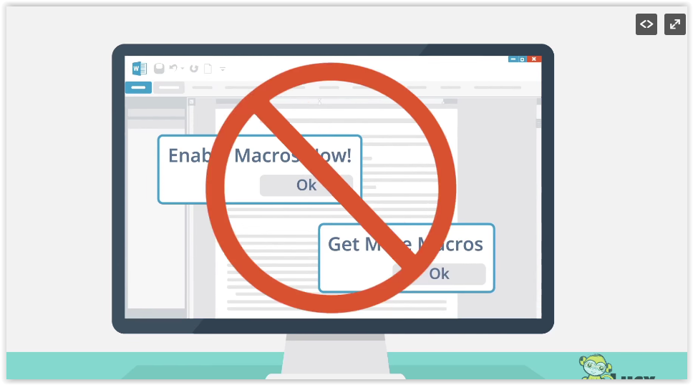
27 | Never plug in USB devices from untrusted sources |  | 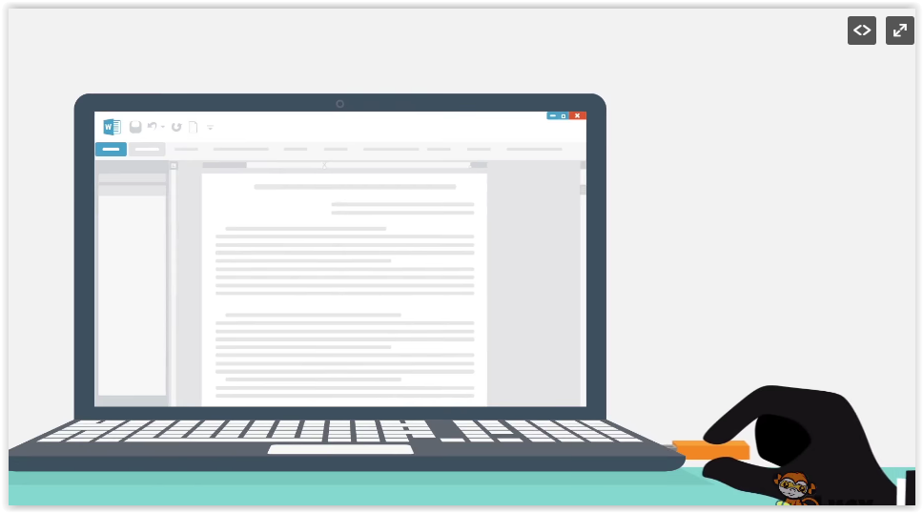
28 | Create regular back Ups of your data |  | 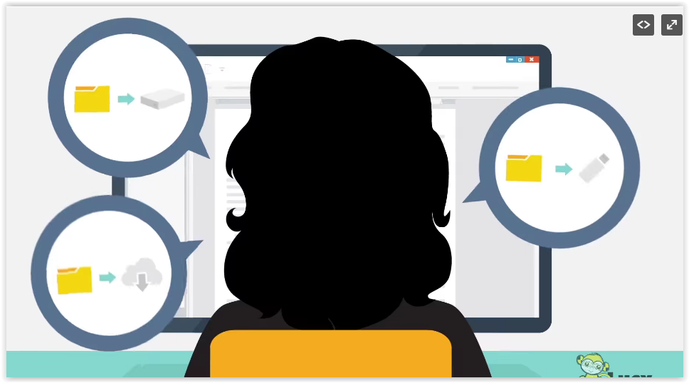
29 | But make sure you disconnect your externals towards devices when not in use |  | 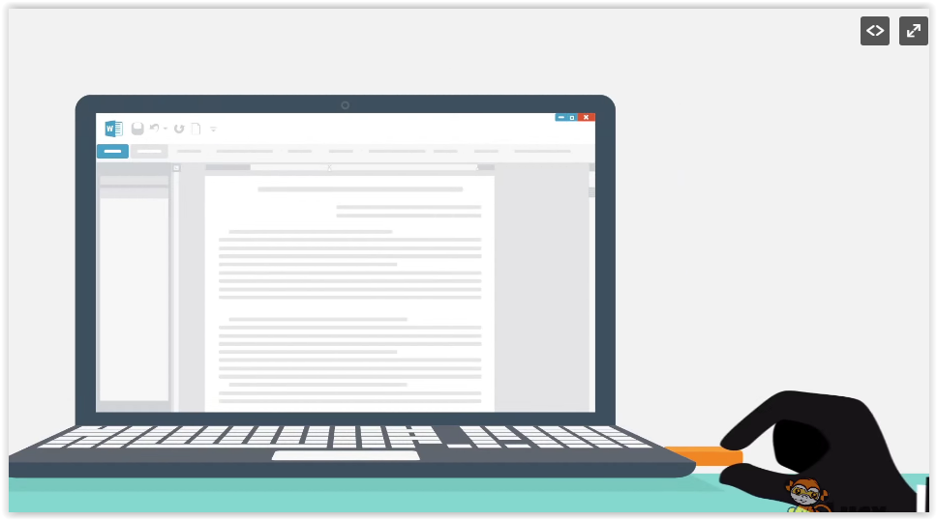
 | If you follow this safeguard and |  | 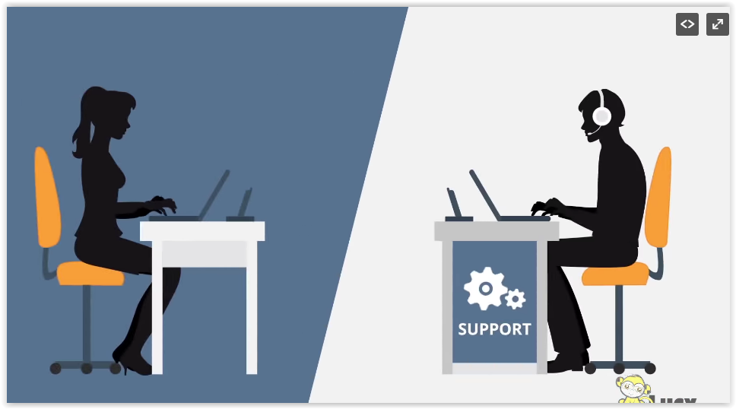  SUPPORT
31 | Report any suspicious to your IT department right away. |  | 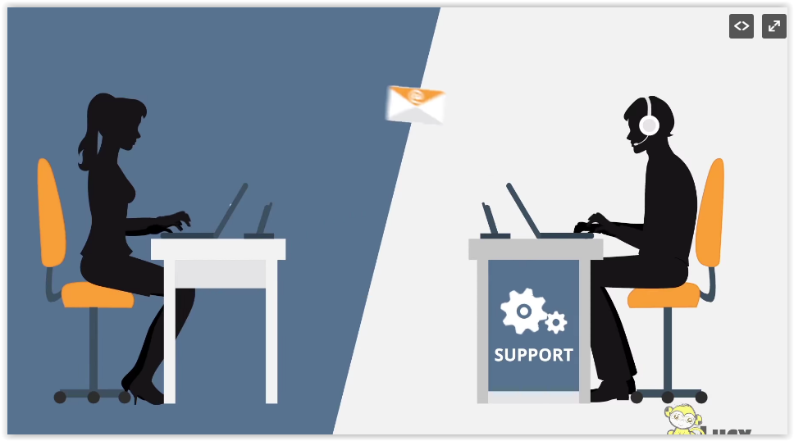
32 | You do your part to protect as from ransomware |  | 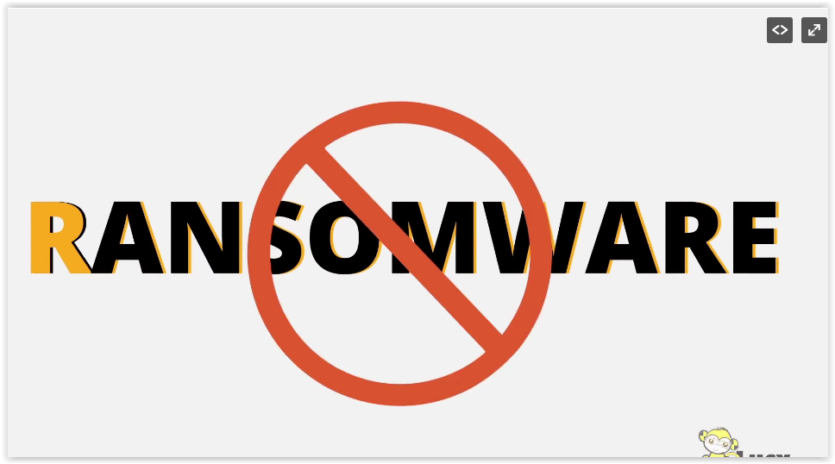
33 | Thank you and be safe! |  | 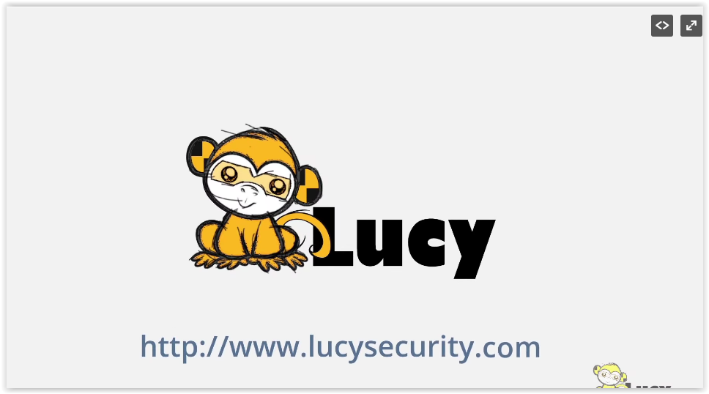
34
35
36
37
38
39
40
41
42

