SAMPLE Lucy Movie Storyboard “Password Security Video”

Introduction: Each LUCY Video is split up in different scenes / animations. This video script covers the Password Security Video
If you want only a few selected scenes to be altered choose the according scene and provide us with the customized text and a draft of the desired animation. Within the field “animation description” you can specify the details of the animation.

Price calculation: A modification costs about around 100 USD per scene (depends on the complexity of the desired animation). So, if you only want to change the logo at the beginning and the end with the intro voice change it will cost 200 USD. The creation of a customized new video of about 2 mins length with a voice of your choice starts from USD 2’000 (includes voice & image/animation design).

# | Voice-over | Animation Plan | Storyboard
1 | This is a LUCY password security video |  | 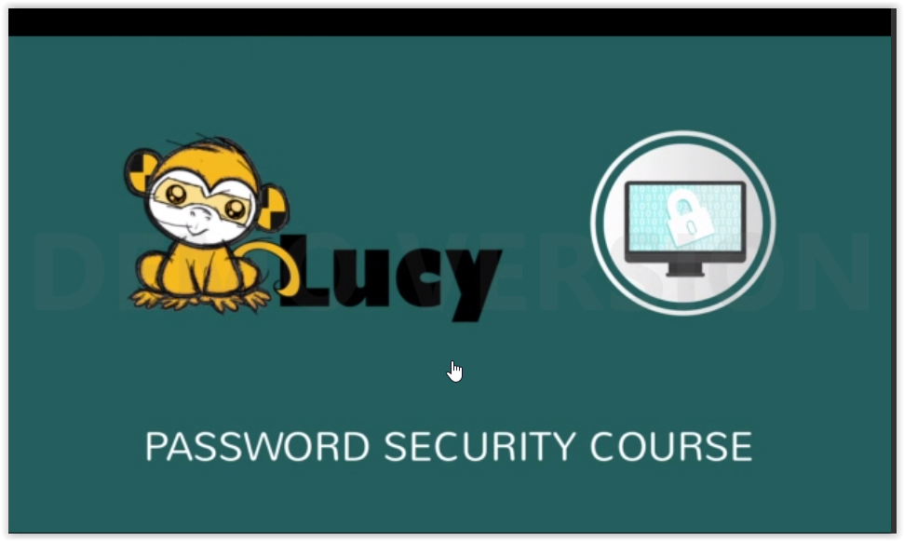
2 | So let’s talk about passwords. |  | 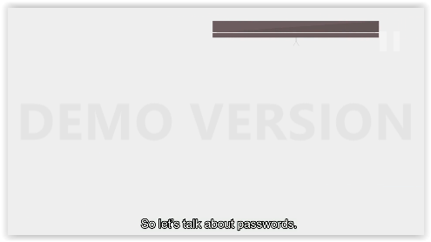
3 | Passwords select keys to your home, but online |  | 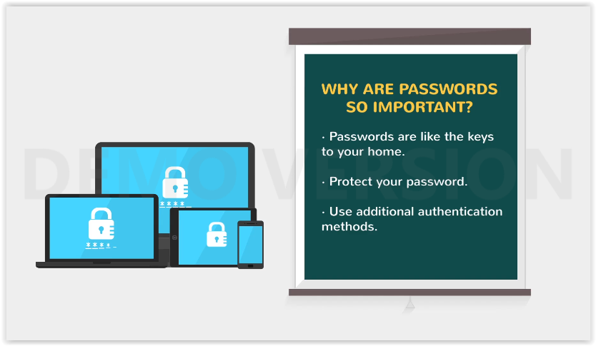  WHY ARE PASSWORDS SO IMPORTANT?  -Passwords are like the keys to your home.  -Protect your password.  -Use additional authentication methods.
4 | You should do everything you can prevent people for gaining access to your password.
5 | You can also futher secure on you accounts by using additional authentication methods.
6 | Dictionary programs are one of many tools frequently used to crack passwords. |  | 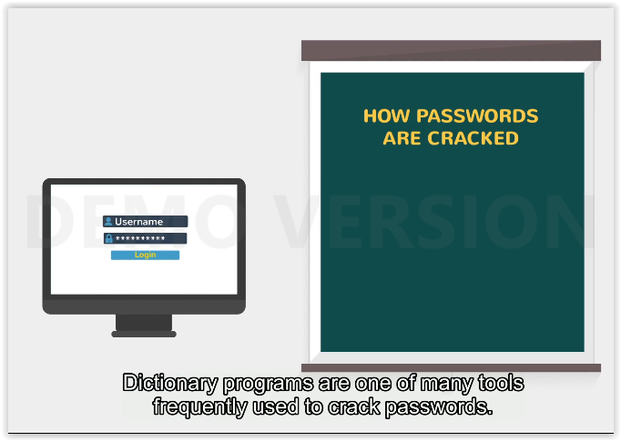  HOW PASSWORDS ARE CRACKED  Username  Login
7 | A hacker will launch a dictionary attack by passing every word through a dictionary |  | 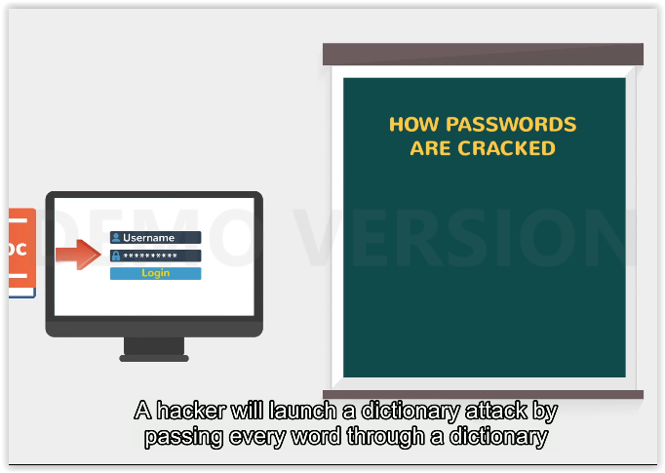
8 | (which can contain foreign languages in addition to the entire English language) |  | 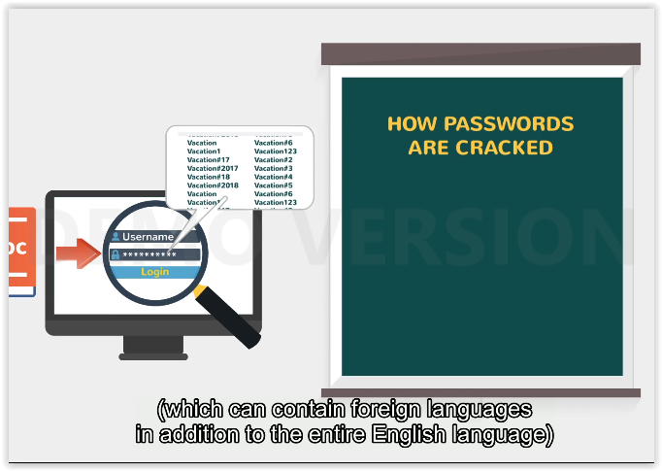
9 | to a login program hoping that a word will eventually match the correct password. |  | 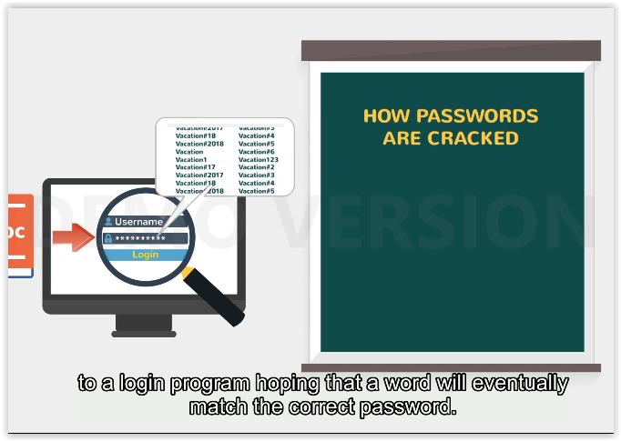
10 | to a login program hoping that a word will eventually match the correct password. |  | 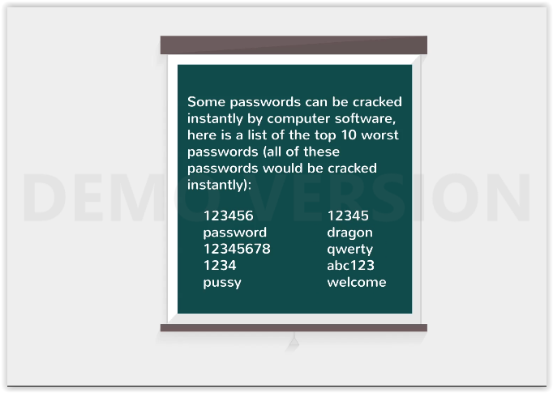

11 | Some passwords can be cracked instantly by computer software, here is a list of the top 10 worst passwords |  | Some passwords can be cracked instantly by computer software, here is a list of the top 10 worst passwords (all of these passwords would be cracked instantly):
12 | (all of these passwords would be cracked instantly)
13 | Passwords become more secure as you add more layers of security to them. |  | 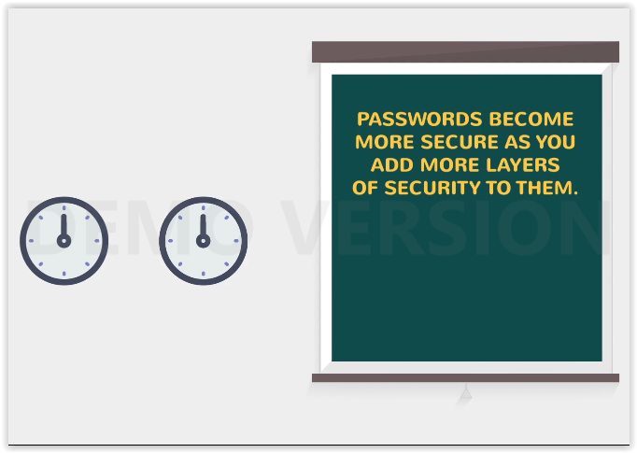  PASSWORDS BECOME MORE SECURE AS YOU ADD MORE LAYERS OF SECURITY TO THEM.
14 | For example, if you use a password like ”Mankato”, it would take about 4 minutes to be cracked. |  | 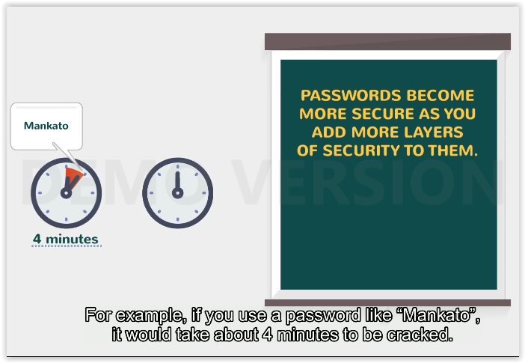  4 minutes
15 | If we add an extra layer of security to our password such as numbers or special characters |  | 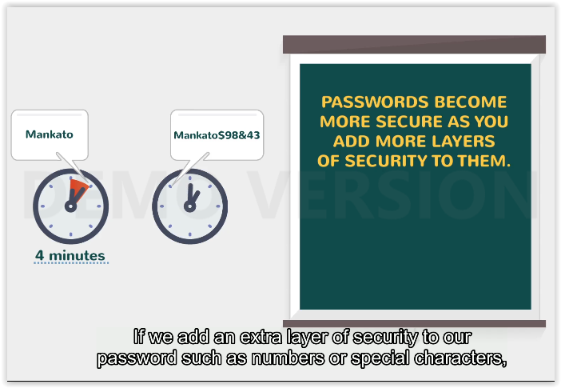
16 | we get passwords that take much longer to crack. Want to know how to make your password secure? |  | 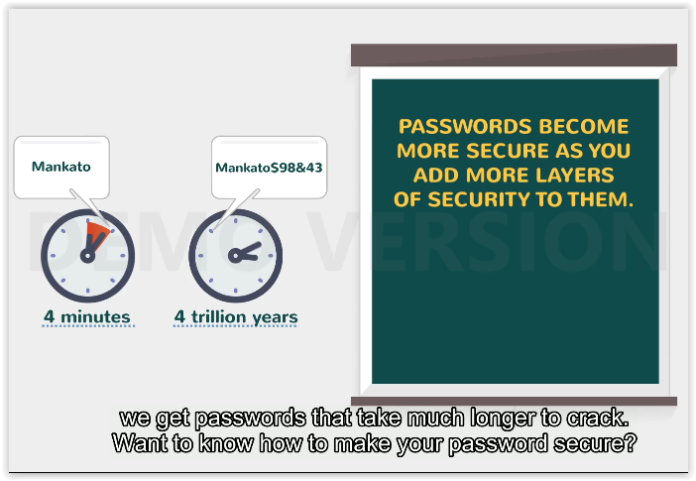  4 minutes  4 trillion years
17 | we get passwords that take much longer to crack. Want to know how to make your password secure? |  | 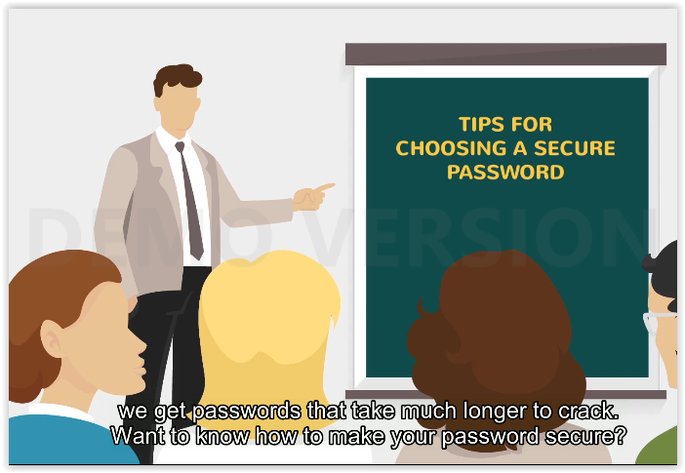  TIPS FOR CHOOSING A SECURE PASSWORD
18 | Tip1: Don’t Use The Same Password Over And Over Again |  | 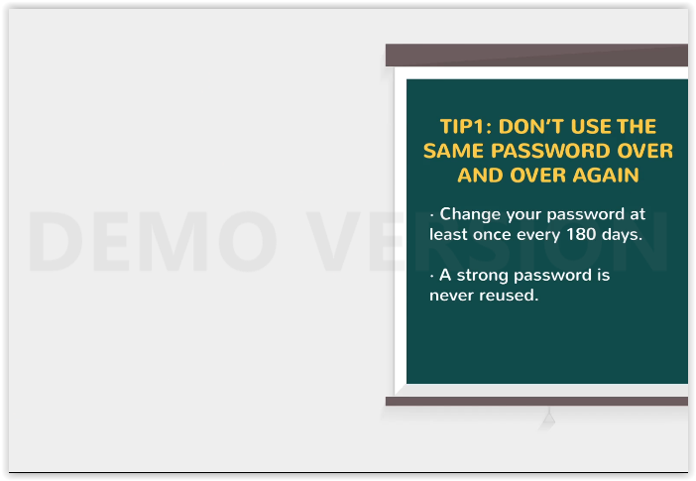  TIP1: DON’T USE THE SAME PASSWORD OVER AND OVER AGAIN  -Change your password at least once every 180 days.  -A strong passwords is never reused.
19 | Password should be changed on a regular basis, at least twice a year. |  | 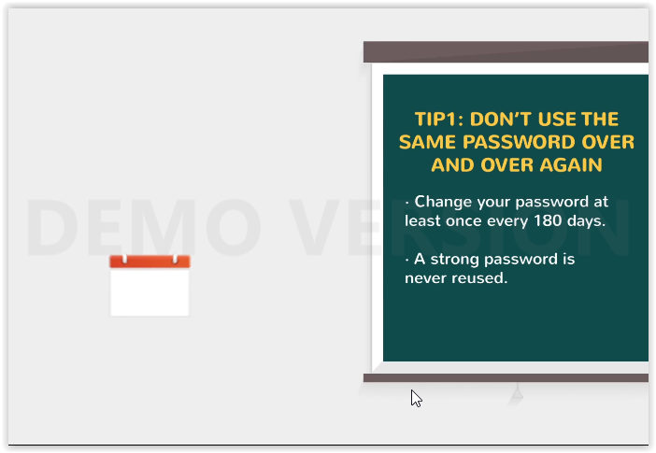
20 | Primary reason is that if someone has cracked your password without you being aware of it, |  | 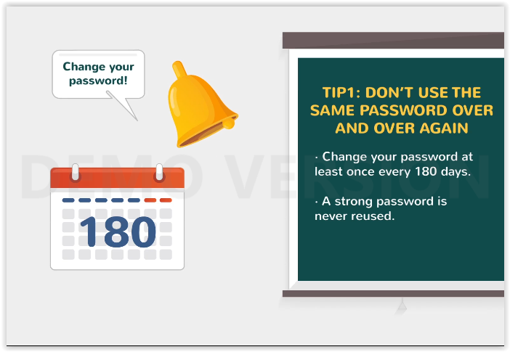  Change your password!
21 | it makes them have to start all over again. |  | 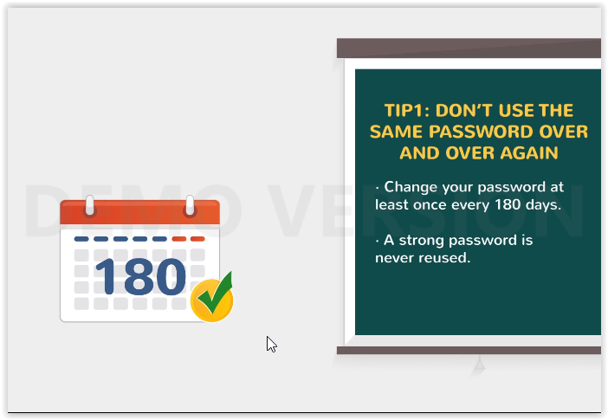
22 | A strong password is one that’s never reused.
23 | Tip 2: Categorize Your Passwords in all to minimize the number of password you have to remember |  | 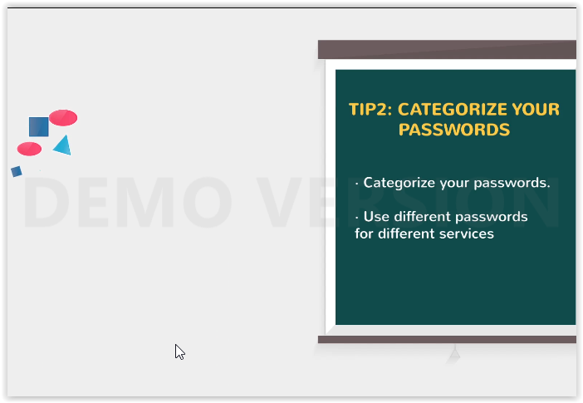  TIP2: CATEGORIZE YOUR PASSWORDS  -Categorize your passwords.  -Use different passwords for different services
24 | But also to provide variant between system with sensitive informaton and those with non-sensitive information. |  | 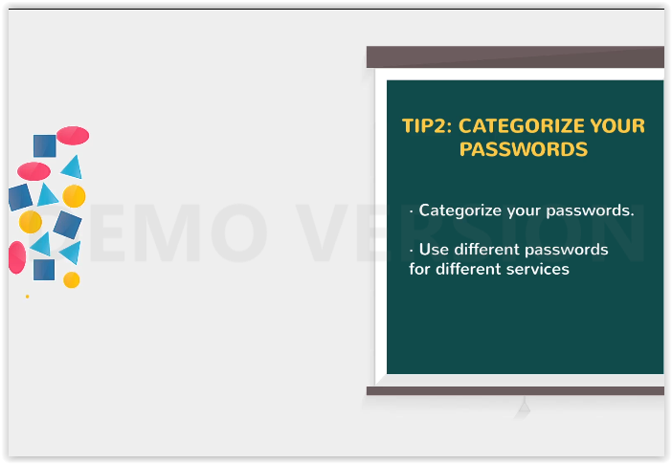
25 | For example, you can use the same password for Gmail and Hotmail |  | 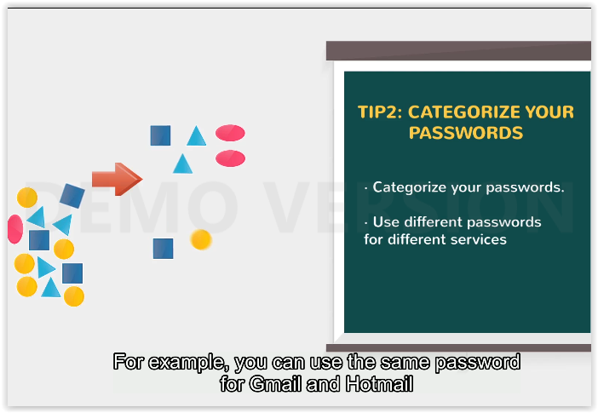
26 | but you should not use the same password for your online banking program. |  | 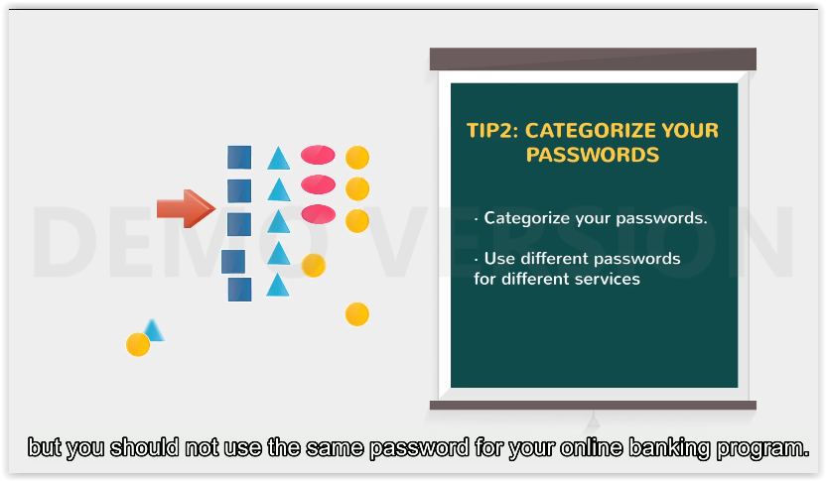
27 | Password you have for Hotmail or other internet email services |  | 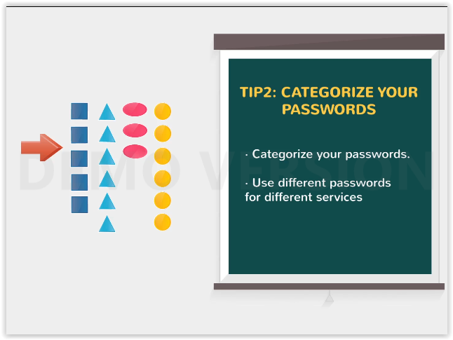
28 | should be different than the password you use on any web related systems
29 | Tip 3: It is important not to reuse password and to change your passwords on a regular basis. |  | 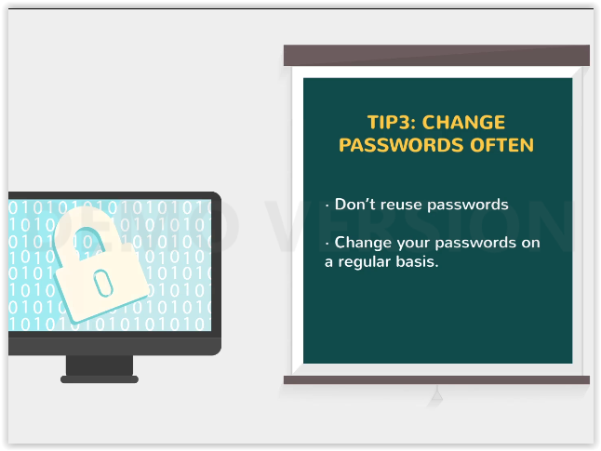  TIP3: CHANGE PASSWORDS OFTEN  -Don’t reuse passwords  -Change your passwords on a regular basis.
30 | Tip 4: Instead of people guessing passwords, now computers are guessing passwords. |  | 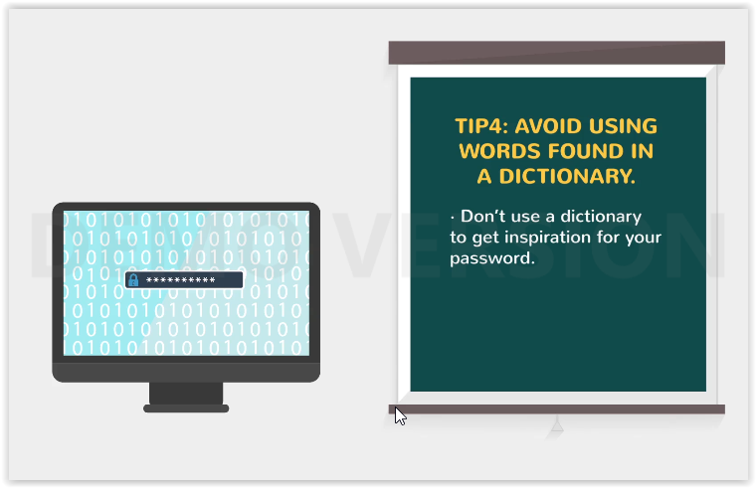  TIP4: AVOID USING WORDS FOUND IN A DICTIONARY.  -Don’t use a dictionary to get inspiration for your password.
31 | For this reason, if your password is made up of words found in a dictionary, |  | 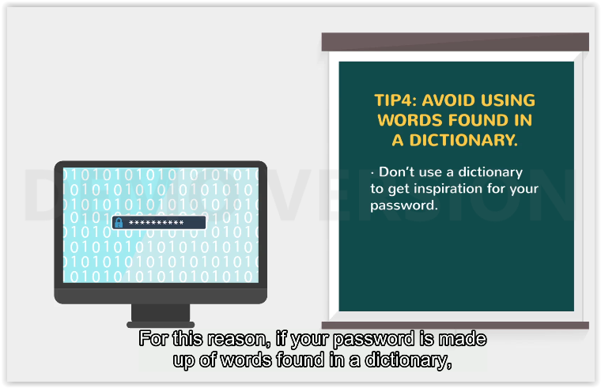
32 | it is very easy for a computer to guess it and gain accss to your account. |  | 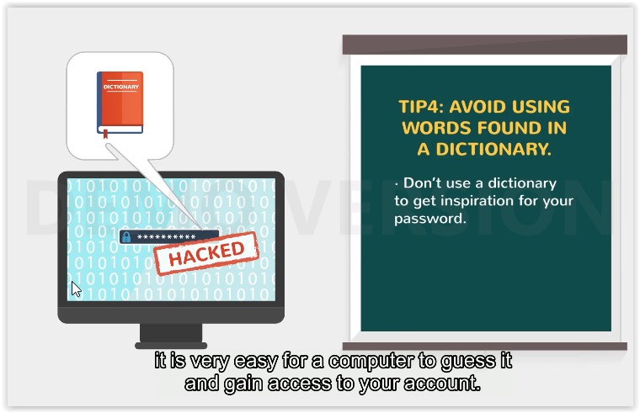  HACKED
33 | Tip 5: A password should be at least eight characters long. |  | 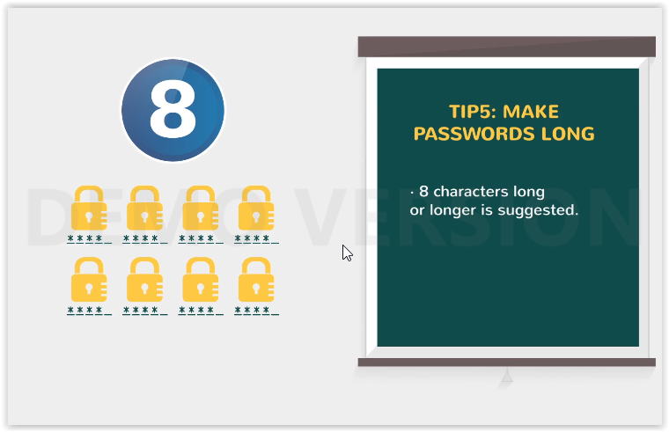  TIP5: MAKE PASSWORDS LONG  -8 characters long or longer is suggested.
34 | Tip 6: Moreover, use uppercase, lowercase, special characters, and number in your pasword. |  | 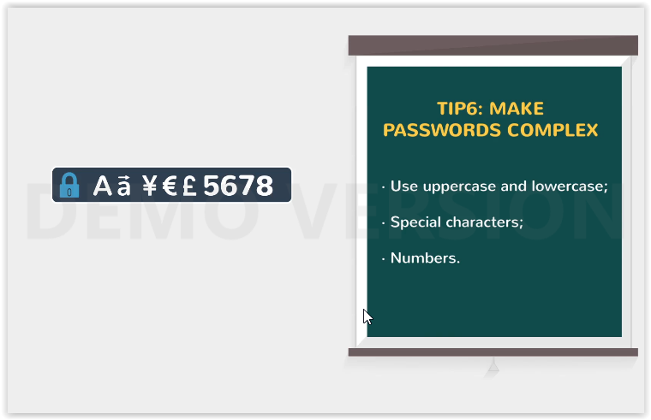  TIP6: MAKE PASSWORDS COMPLEX  - Use uppercase and lowercase;  - Special characters;  - Numbers

35 | Tip 7: Try note to reuse one of your last five password in any form of iteration. See example on the screen. |  | 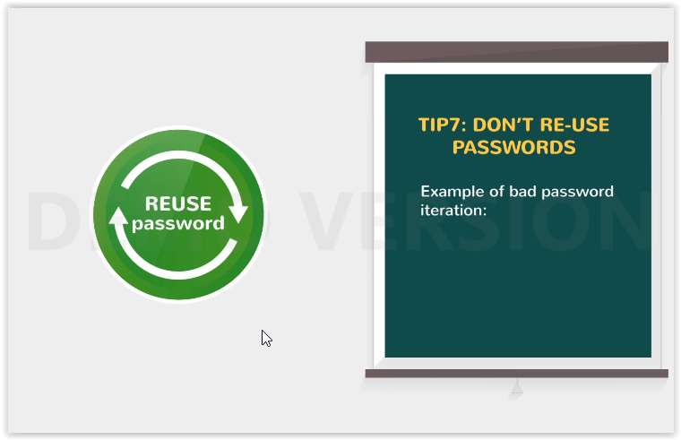  TIP7: DON’T RE-USE PASSWORDS  Example of bad password iteration:
36 | phone number, pet’s name, or other information that may be on social networking profiles, |  | 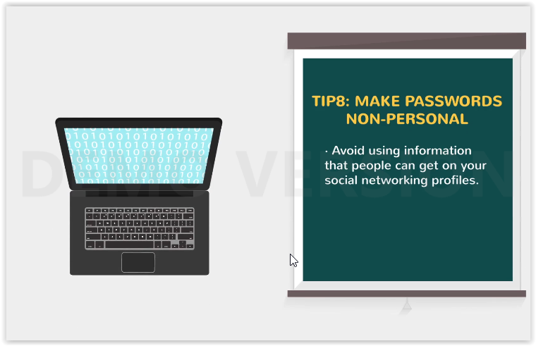
37 | public records, or otherwise easily found or guessed. |  | 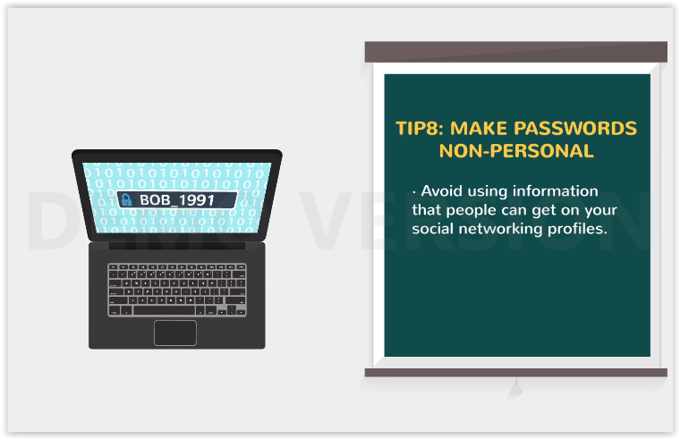
38 | Tip 9: If you absolutely need to write down a password never store to obvious places |  | 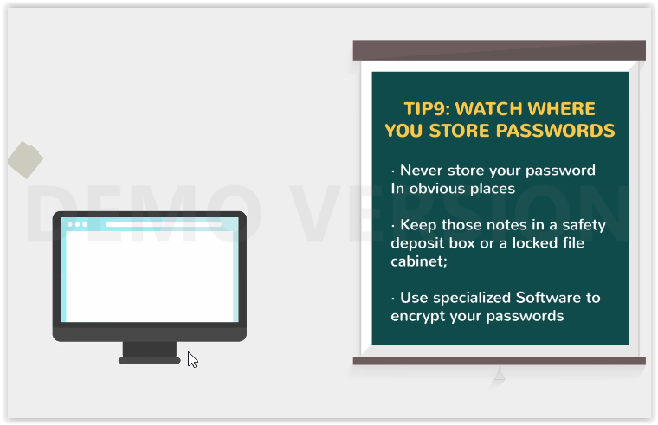  TIP9: WATCH WHERE YOU STORE PASSWORDS  - Never store your password in obvious places  - Keep those notes in a safety deposit box or a locked file cabinet;  - Use specialized Software to encrypt your passwords
39 | such as address books, rolodex files, under drawers or keyboard, or behind of pictures. |  | 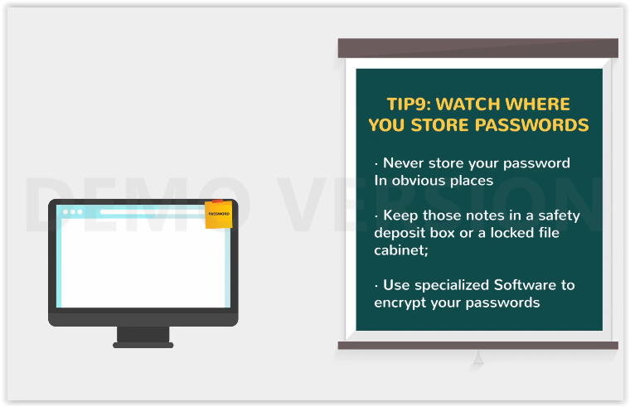
40 | The worst, but all too common locations, is a post-it note near the computer. |  | 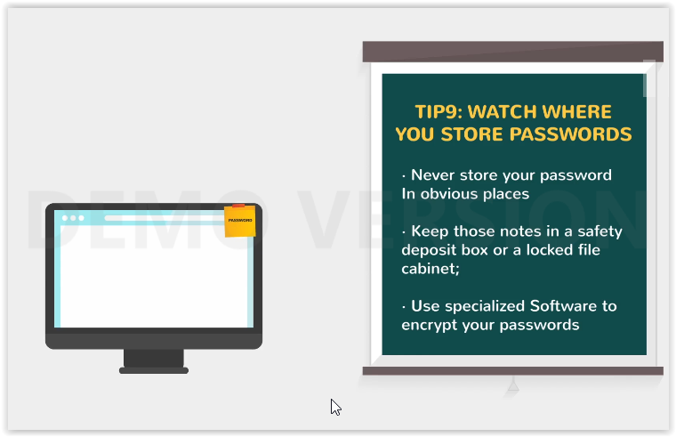
41 | Better locations is are safety deposit box or a locked file cabinet. |  | 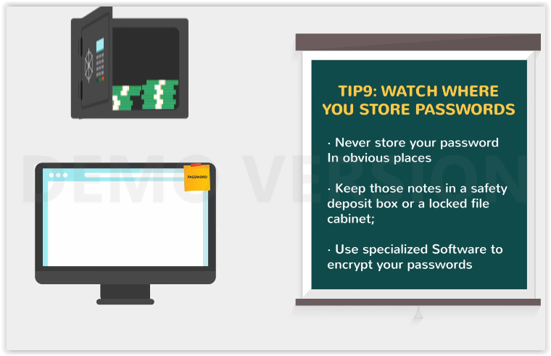
42 | Software is available for hand-held PC that can store passwords for numerous accounts in encrypted form. |  | 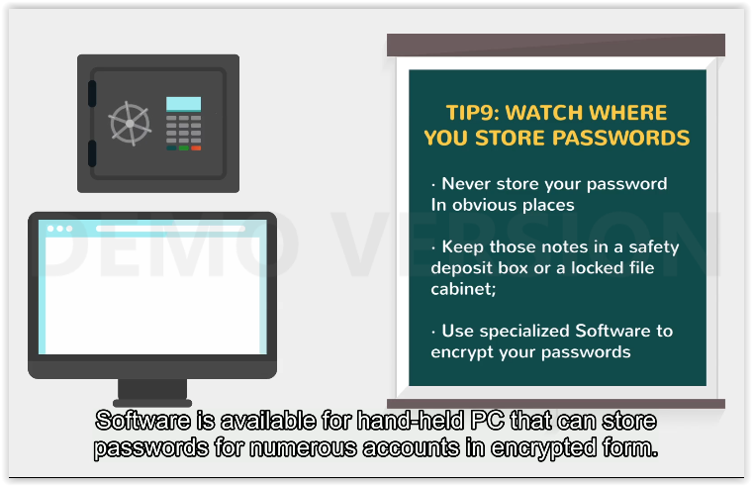
43 | Tip 10: Public computers may not always be securely configured and can pose a threat to your privacy by storing your passwords or web cookies. |  | 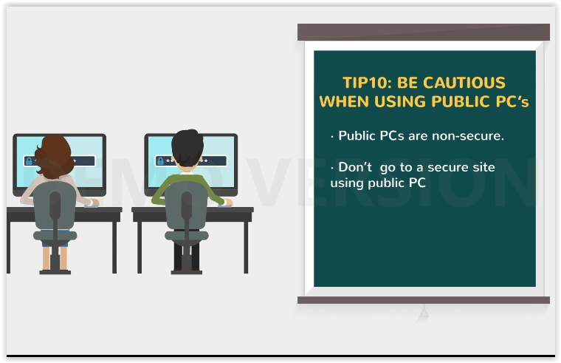  TIP10: BE CAUTIOUS WHEN USING PUBLIC PC’s  -Public Pcs are non-secure.  -Don’t go to a secure site using public PC
44 | Think twice about going to a secure site if you cannot verify the security of the computer. |  | 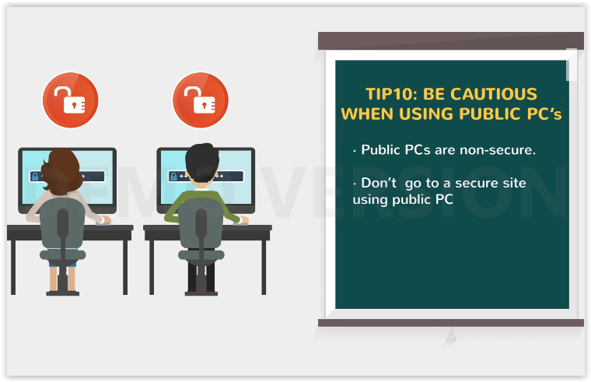
45 | Tip 11: Don't forget that getting password by manipulation of uses is an example of social engineering. |  | 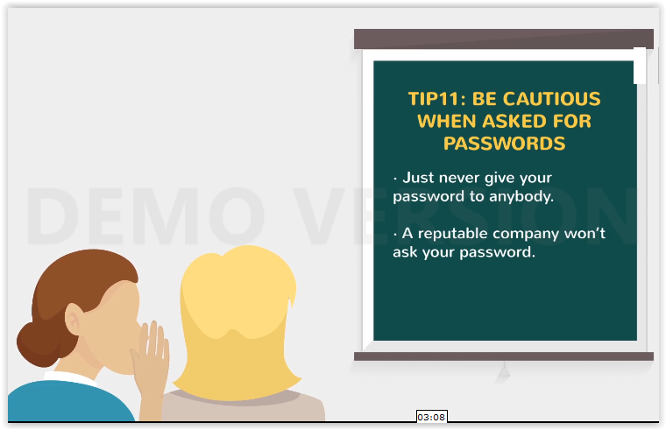  TIP11: BE CAUTIOUS WHEN ASKED FOR PASSWORDS  -Just never give your password to anybody.  -A reputable company won’t ask your passwod.
46 | An attacker might telephone a user and say ”Hi, OIT here. We’re doing a security test. |  | 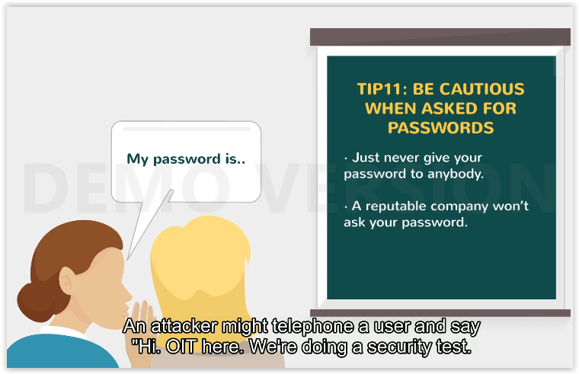  My password is...
47 | Can we have your password so we can proceed?” |  | 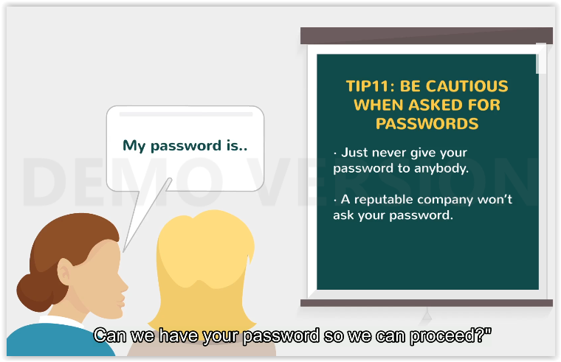
48 | Know that any reputable company you do business with will never ask you for your password |  | 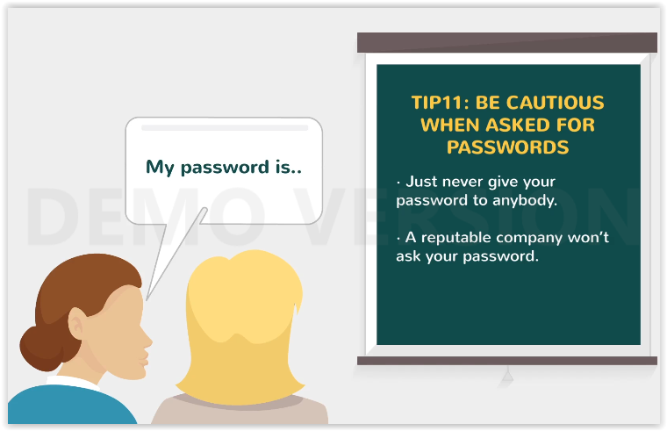
49 | and really if ever need to know your password in order to perform the work |  | 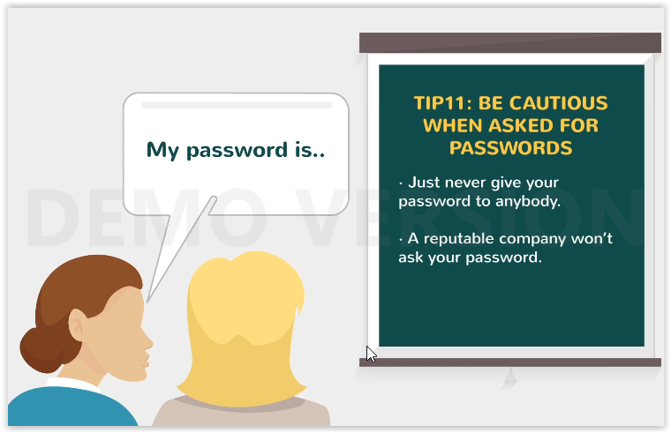
50 | Keep your data to safe and be cautious. |  | 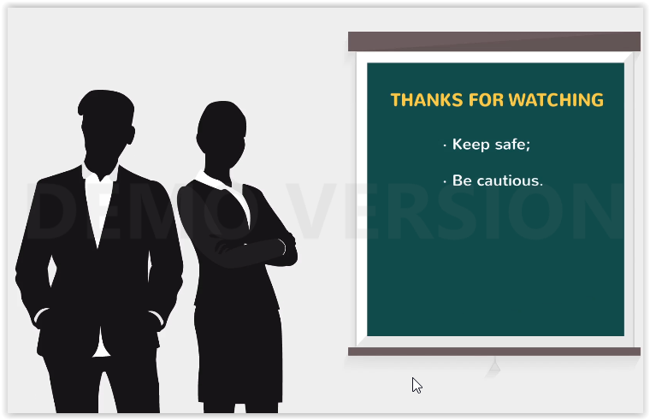  THANKS FOR WATCHING  -Keep safe;  -Be cautious.

